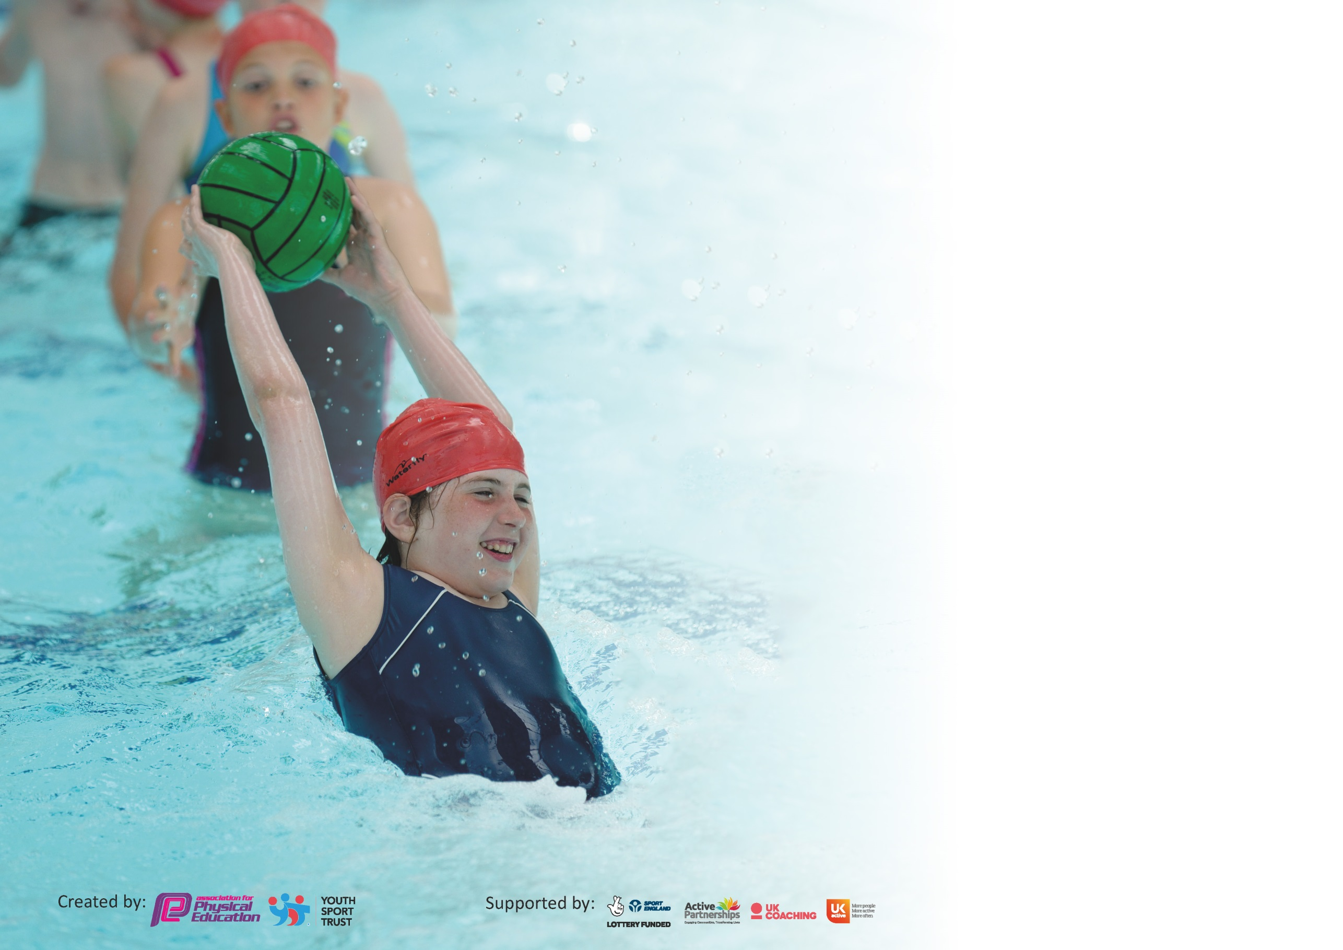

It is important that your grant is used effectively and based on school need. The Education Inspection Framework (Ofsted 2019 p64) makes clear there will be a focus on ‘whether leaders and those responsible for governors all understand their respective roles and perform these in a way that enhances the effectiveness of the school’.

Under the Quality of Education criteria (p41) inspectors consider the extent to which schools can articulate their curriculum (INTENT), construct their curriculum (IMPLEMENTATION) and demonstrate the outcomes which result (IMPACT).

To assist schools with common transferable language this template has been developed to utilise the same three headings which should make your plans easily transferable between working documents.

Schools must use the funding to make additional and sustainable improvements to the quality of Physical Education, School Sport and Physical Activity (PESSPA) they offer. This means that you should
use the Primary PE and Sport Premium to:

- Develop or add to the PESSPA activities that your school already offer
- Build capacity and capability within the school to ensure that improvements made now will benefit pupils joining the school in future years

Please visit gov.uk for the revised DfE guidance including the 5 key indicators across which schools should demonstrate an improvement. This document will help you to review your provision and to report your spend. DfE encourages schools to use this template as an effective way of meeting the reporting requirements of the Primary PE and Sport Premium.

We recommend you start by reflecting on the impact of current provision and reviewing the previous spend.

Schools are required to publish details of how they spend this funding as well as on the impact it has on pupils’ PE and sport participation and attainment by the end of the summer term or by 31st July 2020 at the latest.

We recommend regularly updating the table and publishing it on your website throughout the year. This evidences your ongoing self-evaluation of how you are using the funding to secure maximum, sustainable impact. Final copy must be posted on your website by the end of the academic year and no later than the 31st July 2020. To see an example of how to complete the table please click HERE.

Support for review and reflection - considering the 5 key indicators from DfE, what development needs are a priority for your setting and your pupils now and why? Use the space below to reflect on previous spend and key achievements and areas for development.

Key achievements to date until July 2020: | Areas for further improvement and baseline evidence of need:
- Second year having Sportsmark Platinum  - 5K Challenge – Y4 7th out of 14, Y6 12 out of 17 teams.  - X-Country October top 20 finishers – Y3 Boys Krenar 12th, Y3 Girls Dehanna 8th, Y4 Girls Leah 16th, Omnya 18th, Y5 Girls Naledi 8th, Y6 Boys Enzo 17th.  - Girls Table Tennis 4th  - Sportshall Athletics – Team 3rd (out of 24). Boys – Obstacle Relay 2nd, 6 lap paarlauf 3rd, chest push 3rd, standing triple jump 3rd, vertical jump 1st and javelin 1st. Girls – Obstacle relay 2nd, over/under relay 1st, 4x1 lap relay 2nd, chest push 3rd, speed bounce 3rd, standing long jump 3rd, standing triple jump 2nd, vertical jump 2nd.  - Basketball League – Shield Cup Winners  - X-Country December – Y3 Boys – Krenar 9th, Y3 Girls – Dehanna 9th, Y4 Girls – Demi-Leigh 17th, Y5 Girls Naledi 16th, Y6 Boys – 11th.  - SSPAN Basketball 3rd in group and qualified for the finals.  - Disability Sportshall Athletics – Team 2nd. Farhan 3rd place individual boy. Farhan, Mikhail & Cohen all achieved UKA Bronze Award Disability Sportshall Athletics badge.  - Farahan, Mikhail & Cohen were selected for the All Stars Team for the County Disability Sportshall Athletics Team and achieved the UKA Bronze Award again.  - Table Tennis League – Won the group. Alitaha – Top boy performer. Arihanna – Top Girl Performer.  - Dance – Freya was Star Performer  - Gymnastics – Key Steps 1 Team Bronze, Key Steps 2 Mia – Individual Silver  - X-Country February – County Qualifiers – Y3 Boys Krenar, Y3 Girls Dehanna, Y4 Girls Demi-Leigh & Leah, Y5 Girls Naledi, Y6 Boys Enzo  - Quicksticks Hockey – Spirit of the Games Winners  - Netball League – Won all 3 games in the first round – competition not completed.  - Boys Football League – Boys sitting 2nd in the table in the B Division.  - Girls Football League & Girls football coaching showing skill development.  - Gifted & Talented Camp for Y5 – Postponed  - SSPAN has recognised Marriott for their support, commitment and engagement of virtual programmes during the Summer Term  - SSPAN has recognised Marriott for their ongoing commitment and achievement in the School Games Programme during the Autumn & Spring Terms  MARCH 2020 – SCHOOLS CLOSE DUE TO COVID19 | Assessment process needs to be put in place.  Continue to work on developing opportunities for children who do not want to engage in Physical Education.  Swimming – more students hitting government targets by the end of Y6.

Meeting national curriculum requirements for swimming and water safety.
What percentage of your current Year 6 cohort swim competently, confidently and proficiently over a distance of at least 25 metres?  N.B. Even though your pupils may swim in another year please report on their attainment on leaving  primary school at the end of the summer term 2020. | 29%
What percentage of your current Year 6 cohort use a range of strokes effectively [for example, front crawl, backstroke and breaststroke]?  We normally test Y6 in the summer term but unable to do so due to COVID 19. | 29%
What percentage of your current Year 6 cohort perform safe self-rescue in different water-based situations? | 29%
Schools can choose to use the Primary PE and Sport Premium to provide additional provision for swimming but this must be for activity over and above the national curriculum requirements. Have you used it in this way? | Yes – Paid for an extra teacher so we could have 4 groups instead of 3.

Action Plan and Budget Tracking
Capture your intended annual spend against the 5 key indicators. Clarify the success criteria and evidence of impact that you intend to measure to evaluate for pupils today and for the future.

Academic Year: 2019/20 | Total fund allocated: £ | Date Updated: April 2020
Key indicator 1: The engagement of all pupils in regular physical activity – Chief Medical Officer guidelines recommend that primary school pupils undertake at least 30 minutes of physical activity a day in school |  |  |  | Percentage of total allocation:
 |  |  |  | £520
Intent | Implementation |  | Impact
Your school focus should be clear what you want the pupils to know and be able to do and about  what they need to learn and to  consolidate through practice: | Make sure your actions to achieve are linked to your intentions: | Funding allocated: | Evidence of impact: what do pupils now know and what can they now do? What has changed?: | Sustainability and suggested next steps:
KS2 - Daily Mile – to improve the Health of students by increasing their activity by an extra 15 minutes.  KS1 – Activate – students to complete an activate session each day.  Bikeability training for Year 6  Walk to school  Bike or scoot to school  Active lunchtimes for students.  Inter Class and Level 1 Competitions  Supermovers/Go Noodle  Playground Leaders  Inclusive Football  Children and young people should aim  to minimise the amount of time spent  being sedentary, and when physically  possible should break up long periods  of not moving with at least light  physical act Children and young people should aim  to minimise the amount of time spent  being sedentary, and when physically  possible should break up long periods  of not moving with at least light | Have different routes for the students to complete. Competition between the classes. Try it skipping, dribbling etc.  Teachers select different routines for the students to perform.  Encourage students to bike to and from school.  Staff to record those students who are walking to school, so that they can achieve their badges.  A range of activities for students to be involved in at lunchtime. Some competitions also taking place to encourage students.  Skipping every Tuesday lunchtime.  Training for lunchtime supervisors.  Competitions between the classes to increase participation and raise activity levels. Run competitions at the end of a unit of work.  Staff to choose areas which they want to work on with their class to get them active in the classroom e.g. 8 X Tables with Filbert Fox  Y5 training at the start of the Academic Year. Teachers to put their student’s on rotation for each term.  Coach works in school delivering football to students who have SEND. | Skipping Coach  £520  Staff Training  Use PE Equipment  Photocopying Booklets and Certificates. | All pupils involved in an additional 15 minutes of exercise a day.  All pupils involved in an additional 15 minutes of exercise a day.  An increase in students bringing their bike to and from school.  Students receiving their badges when they achieve targets. Improved health, social and environmental benefits.  Students involved in different activities at lunchtime e.g. Table Tennis, Skipping, Cricket, Netball, Basketball etc.  Students involved in representing their class and participating in Level 1 Competitions, they gain confidence, discipline and self-belief.  Students are active during lessons and use the routines to help learn different areas of the curriculum. They know that you don’t always have to sit in the classroom to learn other topics.  Y5 Students are out in the KS1 Playground doing activities with the younger students. Improved confidence for the students leading the activities.  All SEND student are involved in activity throughout the year.  WIDER IMPACT  Students are more active in PE lessons.  Improved standards in PE.  Attitudes to learning are improved.  SAT results improved.  Hit the target set by the Chief Medical Officer of being active for at least 30 minutes each day in school, but 60 minutes each day.  Students are less sedentary throughout the day.  Develops movement skills.  Improves muscular fitness and bone strength. | The Daily Mile embedded in the school day.  Activate embedded in the school day.  Encourage students in Y6 to be using their bikes to travel to and from school.  Students receiving their badges when they achieve targets  New bike/scooter sheds available for students to use  Continue to organise activities for students at lunchtime so they can remain active.  Continue to organise Level 1 competitions throughout the year for student’s to be involved in.  Staff to use the resource to support different areas of the curriculum, not the same routine all of the time.  Set up each year with new Y5 classes.  At present, we get the coaching free, but may have to pay in the future if targeted funding is stopped.
Key indicator 2: The profile of PESSPA being raised across the school as a tool for whole school improvement |  |  |  | Percentage of total allocation:
 |  |  |  | %
Intent | Implementation |  | Impact
Your school focus should be clear what you want the pupils to know and be able to do and about  what they need to learn and to  consolidate through practice: | Make sure your actions to achieve are linked to your intentions: | Funding allocated: | Evidence of impact: what do pupils now know and what can they now do? What has changed?: | Sustainability and suggested next steps:
Celebration Assembly to ensure the whole school is aware of the importance of PE and School Sport and to encourage and inspire students to be involved.  Noticeboards celebrating the success of our students and raising the profile of Physical Education and School Sport.  Trophy Cabinet  Role Models visiting school or being met at events.  Social Media – Marriott Twitter and Facebook | Achievement celebrated in Assembly, achievements, results, certificates etc. presented.  Keep all of the displays up to date with the relevant information, competitions, trips, successes and progress. Different noticeboards for Physical Education, Physical Activity, and School Sport.  Trophy Cabinet bought previously and all awards and trophies are on display.  Invite local personalities into school or take students to events to watch and/or meet them.  Update Social Media when at events and with the work going on in school so parents are informed of what we are doing. | SSPAN membership and entry to Leagues.(cost in Section 5)  Printing posters for display. | Pupils enjoy being involved in the Assembly and having their successes celebrated. Achievements can be shared with their parents.  Noticeboard outside of main reception has an updated list of competitions and the results displayed for parents.  Noticeboards in the PE Corridor celebrate Physical Education, Physical Activity & School Sport.  This encourages students to get involved and enjoy representing their school.  Trophy Cabinet displays the achievements of our students.  Inspire children to be involved in Physical Activity within and outside of school.  Allow us to share our activities and achievements with the wider community – parents, teachers, governors and other school etc.  WIDER IMPACT  Pupils are proud to be involved in assemblies and have their achievements displayed on the noticeboards, school website and school twitter etc.  Increased self-esteem /confidence has an impact on learning across the curriculum and when we attend events. | SLT see the benefits of the raised profile and continue their commitment to fund Primary PE and School Sport.  Continue to celebrate the amazing work that we are doing at Marriott. Compete/participate in a variety of events for students to be involved in.  Will need a bigger Trophy Cabinet in the future as it is very full.  Try to get a range of inspirational people in to school to talk to or work with children as well as attending events to inspire children.  Keep making posts on Social Media to celebrate the achievements of Physical Education, Physical Activity and School Sport at Marriott.

Key indicator 3: Increased confidence, knowledge and skills of all staff in teaching PE and sport |  |  |  | Percentage of total allocation:
 |  |  |  | £10,388.22
Intent | Implementation |  | Impact
Your school focus should be clear | Make sure your actions to | Funding | Evidence of impact: what do | Sustainability and suggested
what you want the pupils to know | achieve are linked to your | allocated: | pupils now know and what | next steps:
and be able to do and about | intentions: |  | can they now do? What has
what they need to learn and to |  |  | changed?:
consolidate through practice:
School employs a specialist PE Teacher one day a week to work with the PE Co-coordinator and all of the staff in rotation throughout the year.  CPD provided for staff throughout the year by the PE Specialist or with Future Active or other outside agencies.  Swimming Induction and Wet and Dry Tests  Resources available for staff to access | Use Staff questionnaire to identify areas of training required.  PE Teacher and class teachers to identify what activities will develop their knowledge.  Organise training sessions for staff in a variety of activities e.g. Cricket  Level 3 PE & Sport Course – 1-member staff.  Kimbles – Foundation and KS1  Book staff onto courses that are relevant to their development  Balanceability  BEE Netball  Futsal  Yoga Taster  Mental Health First Aid  REAL Gym  SSPAN Conference  All staff involved in swimming or required to cover swimming have the relevant training.  Safe Practice in PE Book available for staff.  YST Membership  IMOVES Dance Health & Well Being Package  Swim Charter | £9,674.22  CPD  Free  (Apprenticeship Levy for Level 3)  £250  £140  Free Place  Free Place  £45  COVID 19  COVID 19  £10 per staff member  £110  £40  £99  £30 | Improved knowledge for Teachers and Teaching Assistants, so they are more confident when teaching PE.  Increased confidence for running activities at lunchtimes and after school.  Subject Leader more confident when undertaking lesson observation, able to provide feedback and lead discussions.  PE Teacher confident to lead or organise the relevant training for staff.  Teachers more confident when teaching PE because of improved subject knowledge.  Staff use their knowledge to run extracurricular activities, assist on Sports Trips and run activities at lunchtime.  Staff involved in swimming have completed an Induction and the Dry Test and Wet Test if required.  Resources available for staff to access.  WIDER IMPACT  Skills, knowledge and understanding of pupils are increased significantly.  Pupils enjoy Physical Education, Physical Activity and School Sport, they are keen to participate, demonstrate and show a desire to learn and improve. Staff have the knowledge, skills and confidence to inspire children when participating. | All staff will feel supported to be confident when delivering PE and Sport both within the Curriculum and School Sport.  Staff continue to be offered CPD to develop their knowledge in different activities.  Staff to identify if they require cover to attend courses.  Staff identified each year and sessions booked in for the start of the Academic Year and throughout the year as required.  Purchase and make resources for staff to access to develop their knowledge.
Key indicator 4: Broader experience of a range of sports and activities offered to all pupils |  |  |  | Percentage of total allocation:
 |  |  |  | £1,139.24
Intent | Implementation |  | Impact
Your school focus should be clear | Make sure your actions to | Funding | Evidence of impact: what do | Sustainability and suggested
what you want the pupils to know | achieve are linked to your | allocated: | pupils now know and what | next steps:
and be able to do and about | intentions: |  | can they now do? What has
what they need to learn and to |  |  | changed?:
consolidate through practice:
Additional achievements:  Continue to offer a wide range of activities both within and outside the curriculum in order to get more pupils involved in Physical Education, Physical Activity and School Sport  A PE Curriculum, which is varied and progressive that offers a variety of sports/activities to pupils.  Focus on girl’s involvement in sport.  Focus on those students who are sometimes reluctant to be involved in PE and Sport.  Physical Education equipment purchased so students can access the curriculum and extracurricular activities.  Sports kit required for representing the school at Competitions, Festivals or Events.  Smaller groups in swimming so students make more progress. | Arrange for external coaches to work with staff in lessons, clubs or Health Week.  Leicestershire Cricket  Kimbles Health Week  Skipping Health Week  SPARX  WISPA  Archery Health Week  Boxercise Health Week  Grace Road Visit Y6  Mini WHISPA  Inclusive Football Festival at Holmes Park  Tri Golf  Run a club specifically for girls only and provide opportunities for girl’s only events.  Boxercise  Netball  Wildcats  LCFC Coaching  Run a Golden Ticket Club for students who do not always fully engage in Physical Education and School Sport.  PE Equipment purchased.  Sport Team Kit purchased  T-Shirts  Printing  Dance Skirts  GK Gloves & Shinpads  Hire an extra teacher for swimming.  Have staff in the pool to support students skill development and confidence. | COVID 19  £50  COVID 19  COVID 19  £50  COVID 19  COVID 19  COVID 19  COVID 19  COVID 19  COVID 19  £100 –COVID19  £50  COVID 19  £  £116.26  £140  £48  £54.98  £525  COVID 19 | A variety of extra-curricular clubs offered throughout the year, which are run by Teachers and Teaching Assistants, staff are confident running these clubs.  Students have the opportunity to be involved in a variety of different sports and activities which develops their skills and knowledge.  Students develop confidence to be more involved in Physical Education lessons and represent the school at Sport Competitions.  Engaging students in different Physical Activities such as gardening enables them to realise that they can be active at home.  Students have the equipment needed to participate in Physical Education, Physical Activity and School Sport.  Students proud to represent the school in their Marriott kit when they attend Competitions, Festivals and Events.  Students are more confident in the water and making faster progress.  WIDER IMPACT  Improved behaviour in school.  Students actively involved in Physical Education lessons.  Students want to be involved in Physical Education, Physical Activity and School Sport.  Reluctant students engaged in Physical Education, Physical Activity and School Sport. | Staff work together and share good practice, which develops confidence and staff more willing to support competitions and clubs.  Hope to expand the range of extra-curricular clubs.  Provide opportunities to engage students to develop confidence and a joy for Physical Activity.  Identify students who would benefit from a different approach to Physical Activity or want to be involved in female only Physical Activity or Sport which will develop their confidence.  Identify students who would benefit from a different approach to Physical Activity which will develop their confidence.  Monitor what equipment needs to be replaced and/or purchased.  Purchase equipment that is an investment required for the curriculum.  Purchase PE kit that is required for representing Marriott at Competitions, Festivals and Events.  Ensure there is support in the water for students and have an extra teacher so swimming groups are smaller.

Key indicator 5: Increased participation in competitive sport |  |  |  | Percentage of total allocation:
 |  |  |  | %
Intent | Implementation |  | Impact | £4,228.60
Your school focus should be clear | Make sure your actions to | Funding | Evidence of impact: what do | Sustainability and suggested
what you want the pupils to know | achieve are linked to your | allocated: | pupils now know and what | next steps:
and be able to do and about | intentions: |  | can they now do? What has
what they need to learn and to |  |  | changed?:
consolidate through practice:
Enter a variety of competitions and festivals through Leicester City SSPAN and local Leagues.  Focus on SEND to ensure they are involved in the competitions available to them  Organise a range of Level 1 Competitions in school | Enter all of the competitions provided though Leicester City SSPAN including all of the SEND competitions.  Enter the Y5/6 boys Football League, Y5/6 girls Football League, FA Cup and County Cup, Danone Football Cup.  Enter the Basketball League.  Participate in Central Venue competitions at CHCC.  Pitch Hire  DSE National Disability Athletics Championships  Competitions with Mayflower, Spinney Hill & Dovelands Primary Schools.  Daily Mile Celebration  Have a calendar of events for the Academic Year.  Transport | £1,320  £450  £5  £28.60  COVID 19  COVID 19  COVID 19  £2,425 | We are involved in all of the competitions, we track all of the students who represent the school in these competitions.  We run Level 1 competitions so all student can compete throughout the year.  Participation in competitions.  Level 1 – 100%  Level 2 – Y6 – 88%  Y5 – 76%  Y4 – 63%  Y3 –57 %  Unfortunately, our percentages are down this year due to the cancellation of competitions due to COVID19.  WIDER IMPACT  Improved standards in competition activities.  Girls engaged in Girl only and mixed competitions.  SEND involved in Disability competitions and other competitions. | More CPD for staff involved in running clubs.  Continue membership of Leicester City SSPAN.  Organise competitions with other schools to provide different opportunities for students.  Calendar Level 1 Competitions in school.

Signed off by
Head Teacher:
Date:
Subject Leader:
Date:
Governor:
Date:

