Welcome back to school
‘We cannot wait to meet again!’
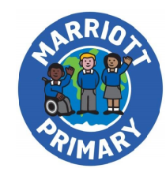

Year 1 Bubble B
The start time for your time in school will be
9:00 AM
The end time for your time in schools will be
3:00 PM
All children will have a free lunch provided by the school. If you wish to have your own lunch it must be in a disposable bag.

The date we will welcome you back will be… Monday 15th June 2020

Your teachers will be Miss Rossell, Mrs Tully and Miss Chapman

Your classroom will be… Alice Hawkins class
You do not have to wear uniform if you do not want to but please come in clean clothes every day.
You will enter via top gate on Marriott Road
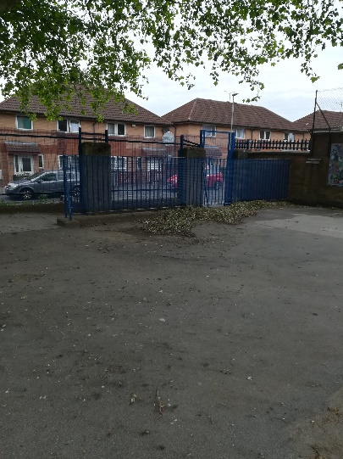
Only 1 parent/carer is allowed to bring you to school and will say goodbye to you for the day here and will be there to collect you at home time. You will need to line up at your sign and stand on a yellow dot.
. 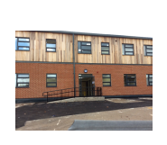
You will enter the school with your teacher here
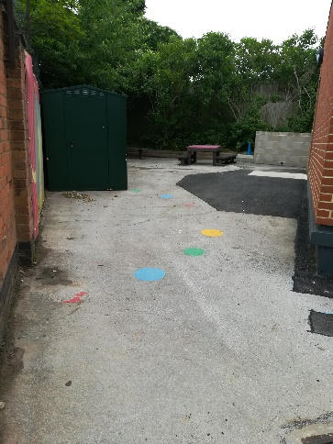
Your class will look like this
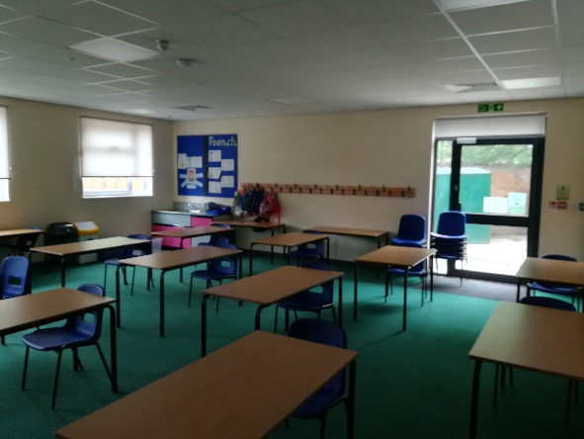
Your playground space will be here. This will give you some fresh air and exercise safely
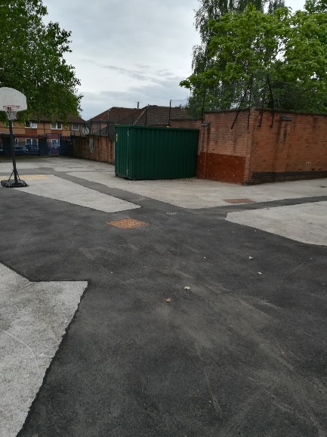

School will look a little different when you return to us
We will have tape on the floor so that all children can be a safe space apart
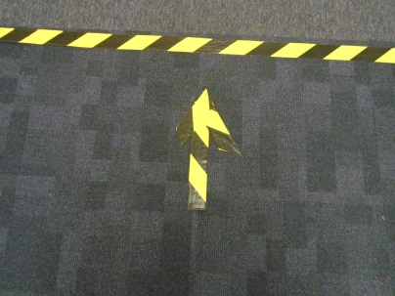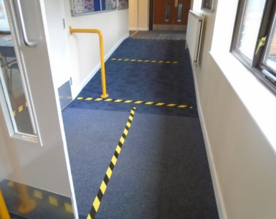

Some adults may need to wear this if they are helping children with an accident or a medical need
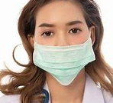

These are the signs that you should look out for and these will help to remind you of what to do each day

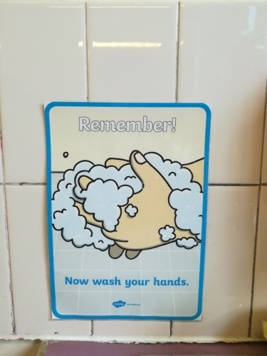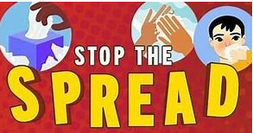

Ways you can help to keep healthy at school
- Wash your hands thoroughly when your teacher asks you too
- Keep a safe distance apart from other children and adults
- Try not to touch things
You will be asked to bring with you today the following items from home
- Water bottle
- Sun cream and hat
- Any medication you may need like your asthma inhaler if it is not already in school.

Other important people
Your first aider will be – Mrs Tully

Your person at the office will be- Mrs Power and Mrs Powell

Your Lunchtime Supervisors will be – Mrs Antwiwaa and Miss Chapman

Quick reminders I must try and remember…
- I won’t be wearing school uniform at the moment – but that is OK
- In the morning I will need to come to school with only 1 of my parents
- I will line up on the 2metre dots on the playground
- I will put my coat on the back of my chair
- I will sit at my desk – I can talk to my friends by I must not get too close
- The school has a new one-way system – I must follow that system all the time
- I must make sure I wash my hands and use the hand sanitiser when my teacher tells me to
- If I feel unwell, or poorly I must tell an adult
- I cannot share my equipment
- My teacher will help me from the front of the class
- I will come back again tomorrow – because school is a great place to be – we have fun, learn new things and look after each other.
- If ANYONE in my family has a cough, temperature or loses their taste or smell then I WILL NOT COME TO SCHOOL.

See you soon at school

