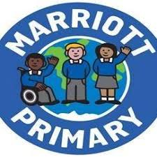

In English we will be the reading the book, “The Fox and the Ghost King” by Michael Morpurgo, to the children as our whole class story.

Our writing will link to our history topic, Rome. We will write diaries, imagining we are new recruits to the Roman Army, and we will learn and retell the myth of Romulus and Remus and how they formed the city of Rome.

The key skills we will focus on are:

1. Writing expanded noun phrases with adventurous vocabulary e.g. the **stern** officer
2. Using adverbs of manner to explain how things are done e.g. the stern officer spoke **loudly**
3. Using prepositional phrases to say where or when it happened e.g. the stern officer spoke loudly **in the training ground**.

* **English/Maths:** Homework is set to consolidate skills taught in class. Sent out on a Friday to be returned the following Thursday.
* **Spellings:** A test each week and new spellings to be learnt given out on a Friday.
* **Reading:** To be practiced regularly at home. Reading books are returned to school on a Friday for new books to be issued on a Tuesday.
* Science - Plants
* Geography - Leicester City and local landmarks
* Art – learning all about the fundamental skills of art and design
* Computing –
* We are learning about everyday vegetables in French. We are also looking at key words and phrases about Christmas.
* In RE, we are looking at the key symbols and meanings in religions and how these are represented.
* We will be focussing on multiplication and division and understanding what they mean and their link to each other.
* There will also be a weekly times table test.
* We are doing hockey, focusing on attacking and defending skills and dance, focusing on our composition skills and body control.

**Mathematics**

**English**

**Year 3** *Spring 1 - 2020/21*

**Half-term newsletter**

**Science, History, Geography, Art, D&T and Computing**

**Homework**

**French**

**Physical Education**

**PSHCE and RE**