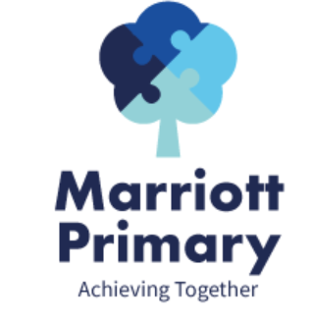
Year 1 Curriculum Newsletter – Autumn 2
Maths
In Maths, this term we are looking at place value to 20. We will be using different apparatus to explore and represent numbers up to 20. We will be mastering addition and subtraction within 10 and ensure we are secure with these number bonds. Children will be learning and practising subitisation. This will support rapid recall in addition and subtraction. We will be exploring shape, geometry, to identify and name 2D and 3D shapes. Number relevance will be part of weekly homework.
English
During this term, we will be looking at the books, Dogger by Shirley Hughes, Monkey Puzzle by Julia Donaldson, Gorilla by Anthony Browne and On the Way Home by Jill Murphy. We will be using the books as a basis for our writing to form sentences, letters, postcards and descriptions. In year 1, we would expect children to write simple sentences and begin to use adjectives (describing words) and conjunctions (and, so and because) to join their ideas together.
Children will continue to use their phonics to segment words before spelling them and will be practising sight words or high frequency words that they should be able to spell by the end of the year.
Science
In Science, we will be classifying animals. We will learn to group animals by their features and similarities. We will learn which animals are herbivores, carnivores or omnivores and how their different features are suitable for their habitats.

Design and Technology (DT)  In DT this half term, we will be creating a moving story book. Using sliders and levers to create these. | Geography  We will be asking the question, ‘what is the geography of where I live?’ Children will look at aerial maps of our local area and understand how where we live is a small part of Leicester.
PE  We will be learning to send and receive using different equipment such as footballs, hockey sticks and balls.  In Dance we will move in a variety of ways, linked to animal movements and be able to work in unison with a partner. | PHSE  We will be learning about our amazing bodies and name the main parts. We will learn about keeping our bodies clean and how to avoid spreading common illnesses and diseases. We will learn about when we are in charge of our bodies and actions.
RE  This half term we will be asking the question ‘who celebrates what and why?’ We will be recognising that different religions celebrate in different ways and for different festivals. | Music  We will explore the different ways we can use our voice to tell a story through music.  We will sing songs from memory using different volume, speak in time to the beat and use actions to engage audience and build storytelling performance skills.  We will listen to songs from different cultural celebrations.

Important Information
- PE is on Monday and Tuesday. Your child may come to school in their PE kit.
- It is important your child reads 3 times a week and sign their log.
- Please complete the homework each week and upload a picture to dojo.

