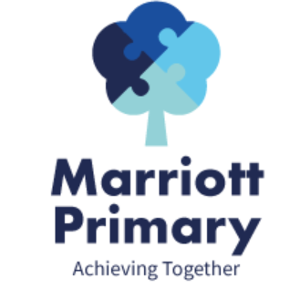
Year 3 Curriculum Newsletter – Autumn 1
Maths
In Maths, we will be beginning with place value, addition and subtraction. We will be looking at numbers up to one thousand. We will compare and order these numbers and identify the value of each digit. Using mental and written methods, the children will learn how to solve a variety of problems.
English
During this term, we will be looking at some RSHE books which will focus on how we can be successful. We will then read Stone Age Boy which will tie in with our history topic. During this half term, we will be focussing our writing lessons on adventure stories and instruction texts. Throughout these units, the children will use a range of conjunctions, adjectives, adverbs of manner and imperative verbs. Punctuation and handwriting will also form a central part of our English teaching this half term.
Science
In Science, we will be finding out about animals and humans. The children will learn about nutrition, diet, functions of the skeleton and how muscles and tendons are used. They will lead their own enquiries into the different functions of the body and compare skeletal structures between animals and humans.

Art  How did prehistoric man make art work?  In Art, we will be creating our own prehistoric art based on ancient cave paintings. The children will learn how to use a range of techniques and mark making skills. | History  How did life for early man compare to today?  We will be exploring the question to find out more about the Stone Age and how this compares to life in Britain today. We will be finding out information from the past using primary and secondary sources to guide our thinking.
PE  Netball and SAQ  We will be taking part in netball and speed, agility and quickness (SAQ). The children will be working on their skills and improving these each week. The children will also take part in the Daily Mile on a regular basis. | RSHE  How can I build positive relationships with others?  In these units, we will be looking at what makes a good relationship and identifying where we can seek support.
RE  What do holy books say about how people should treat others and live their lives?  We will be learning about the declarations of faith and various religious texts across monotheistic and polytheistic religions. The children will also learn to recognise different sacred texts and how they are used in worship. | Music  Notation  This half term, the children will be reading music notation and using this to play tuned instruments. Throughout the unit, the children will be given the opportunity to perform in small groups.

Important Information
- PE is on Monday and Friday. Your child should come to school in their PE kit.
- It is important your child reads 3 times a week and their reading log must be signed and brought to school on a Friday.
- Homework will be handed out every Friday. Please complete the homework each week and upload a picture to Dojo.
- Swimming will begin after Christmas and we will give you more information about this closer to the time.
- The children will be going to Flag Fen on Thursday 4th November.

