[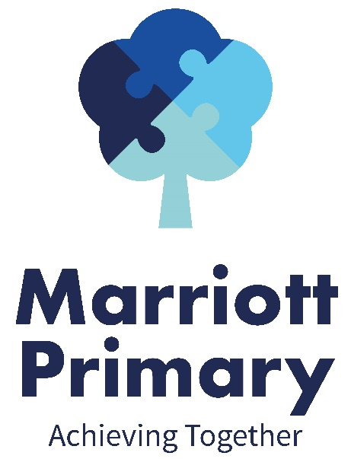](http://www.marriott.leicester.sch.uk/index.asp)

**Science**:

Our science topic this term is “Rocks”. We will be learning all about different types of rock and their different properties. Children will begin to understand how different rocks are formed, what jobs they can be best used for and also how fossils are formed.

**Maths**:

In Maths we will be continuing a big focus on multiplication and division. Children will be tested regularly on their times tables and should know the 2, 5, 10 and 3 times tables by half term.

In lessons we will be focusing on formal methods for multiplication and division, using the tables to work out more complicated calculations.

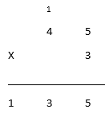 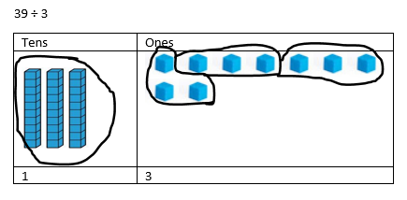

We will then go onto look at measures for volume, mass and length where we will estimate, measure and convert between different units.

**English**:

In English we will be the reading the book, “The Fox and the Ghost King” by Michael Morpurgo, to the children as our whole class story.

Our writing will link to our history topic, Rome. We will write diaries, imagining we are new recruits to the Roman Army, and we will learn and retell the myth of Romulus and Remus and how they formed the city of Rome.

The key skills we will focus on are:

1. Writing expanded noun phrases with adventurous vocabulary e.g. the **stern** officer
2. Using adverbs of manner to explain how things are done e.g. the stern officer spoke **loudly**
3. Using prepositional phrases to say where or when it happened e.g. the stern officer spoke loudly **in the training ground**.

Y3 Curriculum Newsletter

Spring 1 – 2020/21

**History**:

Our history topic this term is Ancient Rome and we will be learning all about how it became the most powerful city in the world and conquered England.

We will be learning about life in the army, the battles they fought to conquer England their Gods and religion and also the many amazing things we have to thank them for.

**Other information:**

Children should read to an adult at least three times every week. This should then be recorded in the reading record. Children who have read three times during a week will then receive a token and a raffle ticket. The tokens go towards helping the class to try and win a film afternoon and the raffle tickets are chances to win a prize. Reading books need to be handed in on a Friday so that they can be changed and returned to you on Tuesday after a quarantine period.

Homework is given out on a Friday to be returned the following Thursday. It will always consist of spellings (on which there is a weekly test), maths and reading comprehension. Please do not return the sheets due to current regulations. Evidence of homework can be put on Dojo by taking a photograph of it. If you need any help with the homework please feel free to contact the teacher through Dojo.

PE is on and and children should come to school on these days in their PE kit.

Children are encouraged to bring water bottles to school as research shows that keeping well hydrated leads to better learning outcomes. Please send them each day with a named bottle.

**RE**:

Our topic is “How does a Christian follow Jesus”. This involves us identifying and understanding the key Christian religious beliefs and teachings and looking at how these lessons influence our lives.

**Computing**:

Our first topic is all about Spreadsheets. We will be using 2Calculate to create tables and using them to make graphs so that the data can be analyised more effectively.

Our second topic is “Touch typing”.

**PE**:

In PE we will be doing orienteering and gymnastics. In orienteering we will be learning how to use equipment and maps to navigate around, solving puzzles and finding out facts along the way. In gymnastics we will focus on learning some simple movements and putting them together into longer routines. They will focus on body control.

**PSHE**:

Our first PSHE topic will be “Healthier and safer lifestyles”. In this unit we will learn about how males and females are different and making sense of our bodies. We will also look at keeping clean and how this will change as we grow.

Put second topic is “Working together” in which we will be looking at the key skills you need to contribute to a team; listening, sharing and playing your part.