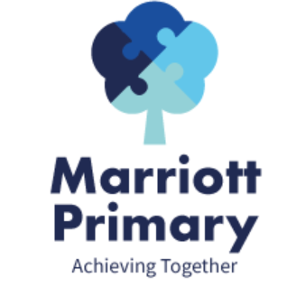
Year 4 Curriculum Newsletter – Autumn 2

Maths
For calculations, we will continue to secure addition and subtraction of four digit numbers and use standard written methods to find answers. We shall also be looking at learning more times tables and calculating written methods of multiplication and division. For our measurement unit, we shall be calculating the length and perimeter of shapes.

English
During this term, we will be basing our writing around a class novel, “Charlotte’s Web”. We shall be basing our writing on key events of the story, focusing on writing dialogue between characters, writing our own narrative and writing a persuasive letter.

Science
In Science, we will be finding out about states of matter. We shall learn how to measure temperature using a thermometer, how materials can change state and focus an investigation around what happens during evaporation.

Important Information
- When it is PE, your child may come to school in their PE kit. See ClassDojo for more information during the term. Swimming is Friday and your child will need their swimming kit and a towel as well as a warm coat. (we will be walking to and from the pool).
- It is important that your child reads at least 3 times a week and their reading log is signed. Book bags, reading books and logs should be brought to school daily
- Please complete the homework each week on Class Dojo (paper copies are available – please ask your teacher.

Art / DT  Textiles - Fastenings  We will learn how to identify and evaluate different types of fastenings and explain the advantages and disadvantages of each fastening type. We shall use this knowledge to create our own Christmas stockings, using fastenings to join different fabrics together. | Geography  How has land use changed and how will it be in the future?  We will be learning how to locate major cities in the UK on map and look at the differences between rural and urban areas. We will investigate why certain land is used for something things and not others and how it has changed over time. In addition to this we will develop our skills on using a compass and identifying basic symbols on a map.
PE  We will be looking at Dance and SAQ (Speed, Agility and Quickness), in addition to weekly swimming lessons. In Dance, children will create a sequence both on their own and with a partner or in a group, thinking about changes in level, speed and timing, using dance to communicate an idea around the topic of Wimbledon.  Swimming will include water confidence and developing swimming abilities and different strokes. | PSHE  What is a healthy lifestyle?  We will identify different ways that we can keep ourselves healthy in lots of different aspects of our life, including our teeth, our diet and our exercise.  What does it mean to be grown up?  We will focus on the human life cycle and the main stages of it, discussing how we change as we get older. We will also look at the different responsibilities we have as children and how they change as we become adults.
RE  We will be focusing on the question: What are the deeper meanings of festivals?  We will look at Diwali, Christmas, Hanukah, Passover and Easter and compare how different religions celebrate festivals. | Music  Brass Band – we will be continuing to learn how to play a brass instrument. We will begin to learn how to read music and understand vocabulary.

