YEAR 6 CURRICULUM NEWSLETTER
AUTUMN 1
Welcome to the Year 6 newsletter for the first half of the Autumn term. As always this is a busy term at school. Children will be receiving regular homework and will be expected to read to an adult at home at least 3 times a week.

SECONDARY TRANSFER | 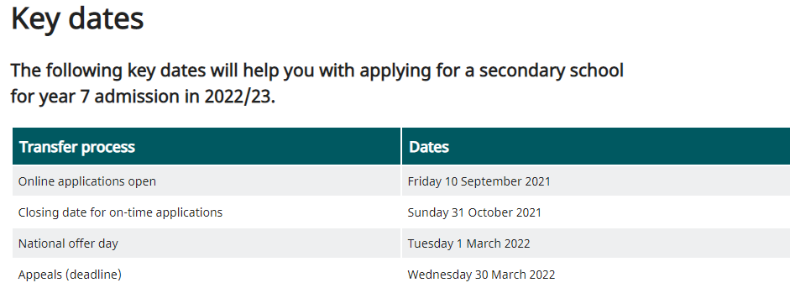  Applying for your child’s secondary school is something that you MUST do before the end of October. We would recommend that you look at local school’s websites and attend any open days/evenings that are running either in person or virtually. That way you will be able to make a considered decision. If you need any help or advice, then please do contact us.  Follow the link below for further information about how to apply:  https://www.leicester.gov.uk/schools-and-learning/school-and-colleges/school-admissions/starting-secondary-school/
SATs | These will take place between Monday 9th and Thursday 12th May 2022. The children will have 6 tests:  - Reading  - Grammar and punctuation  - Spelling  - Maths – Arithmetic (calculations)  - Maths – Reasoning x 2 papers (word problems)  Please ensure that you do not book appointments during these dates.
ENGLISH | This half term the children will write:  - A diary entry  - A recount of our trip to Beaumanor Hall  - A descriptive piece  - Informal letter  - Formal letter  Our class books will be continuing:  - Friend of Foe, Michael Morpurgo  - Letters from the Lighthouse, Emma Carroll  In pieces of writing the children will:  - Plan their writing by:  - identifying the audience for and purpose of the writing (knowing who the reader is)  - noting and developing initial ideas, drawing on reading and research where necessary  - in writing narratives, considering how authors have developed characters and settings in what pupils have read, listened to or seen performed  - Draft and write by:  - selecting appropriate grammar and vocabulary  - in narratives, describing settings, characters and atmosphere and integrating dialogue to convey character and advance the action  - using a wide range of devices to build cohesion within and across paragraphs  Cohesion needs to be achieved in a sentence, within a paragraph and across paragraphs for a text to make sense. Cohesion can be achieved by using: adverbials, punctuation, repetition, pronouns, synonyms and a variety of conjunctions.  - using further organisational and presentational devices to structure text and to guide the reader [for example, headings, bullet points, underlining]  - Evaluate and edit by:  - reading their own and other children’s writing and making edits.  - proposing changes to vocabulary, grammar and punctuation to enhance effects and clarify meaning  - ensuring the consistent and correct use of tense throughout a piece of writing  - ensuring correct subject and verb agreement when using singular and plural, distinguishing between the language of speech and writing and choosing the appropriate register  - proof-read for spelling and punctuation errors
MATHS | PLACE VALUE  - read and write numbers up to 10 000 000  - identify the value of each digit in a number up to 10 000 000  - identify the value of a digit in numbers with three decimal places  - order numbers up to 10 000 000  - compare numbers by working out calculations  - round numbers to a required degree of accuracy  - calculate intervals across zero  - solve problems involving negative numbers in context  - solve reasoning problems using all of the above.  FOUR OPERATIONS (addition, subtraction, multiplication and division)  - multiply numbers by a one-digit number using long multiplication  - solve reasoning questions using the formal method of long multiplication  - divide numbers by a two-digit number using long division  - solve one-step division problems, rounding the answer depending on the context  - divide four-digit numbers by a two-digit number using short division without remainders  - perform one-step mental calculations with increasingly large numbers  - solve reasoning questions involving mental addition, subtraction, multiplication and division  - add and subtract whole numbers using a formal written method  - correctly use the order of operations to carry out calculations  - explore the order of operations using brackets  - find missing numbers using the inverse  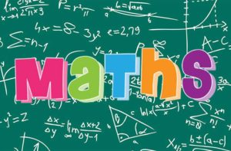  - select the correct operation/s to use and solve a problem, checking the answer using estimation  - solve one-step problems and check their answer using estimation  - round numbers to a specified degree of accuracy  - use rounding to check answers to problems  - sort one-step problems in a sorting diagram  - solve two-step problems involving addition and subtraction.
SCIENCE | LIGHT  How and why do mirrors help us in everyday life?  How do submarines spy on people?  Children will be taught:  - to recognise that light appears to travel in straight lines  - to use the idea that light travels in straight lines to explain that objects are seen because they give out or reflect light into the eye  - to explain that we see things because light travels from light sources to our eyes or from light sources to objects and then to our eyes  - to use the idea that light travels in straight lines to explain why shadows have the same shape as the objects that cast them.  - to work scientifically by: deciding where to place rear-view mirrors on cars; designing and making a periscope and using the idea that light appears to travel in straight lines to explain how it works.  - to look at a range of phenomena including rainbows, colours on soap bubbles, objects looking bent in water and coloured filters (they do not need to explain why these phenomena occur)
HISTORY | WORLD WAR TWO  Did WW2 change Britain for the better?  Children will be taught:  - chronology such as AD/BC, centuries and eras.  - to order significant events, movements and dates on a timeline.  - to describe in detail how some of the things studied from the past affect/influence life today.  - to evaluate evidence to choose the most reliable forms, justifying why.  - to understand that some evidence from the past is propaganda, opinion or misinformation, and that this affects interpretations of history.  - to give reasons why there may be different accounts of history.  - to use: a) novels and play scripts b) information books c) pictures or photograph d) documents and diaries e) DVDs or videos f) the internet g) artefacts h) museum displays to collect evidence about the past.  - to choose reliable sources of evidence to answer questions, realising that there is often not a single answer to historical questions.  - to communicate ideas about from the past using different genres of writing, drawing, diagrams, data handling, drama role-play, storytelling and using ICT.
DT | COME DINE WITH ME (linked to our world war two topic)  - To research and design a three-course meal  - I know how to research a recipe by ingredient  - I understand that not all courses complement one another  - I can list the ingredients I need for my chosen recipe  - I can read the method and make a list of all of the equipment I need for my chosen recipe  - To prepare a meal using a recipe  - To understand where their food comes from  - To write up a recipe  - I can prepare ingredients and follow a recipe safely and sensibly  - I can describe the process of ‘Farm to Fork’ for a given ingredient using a storyboard  - I can contribute an attractive and easily understood recipe page to a class cookbook using imperative verbs, adjectives and illustrations
PE | BASKETBALL  Children will be taught:  - to develop ball handling and familiarisation skills.  - to pivot after stopping.  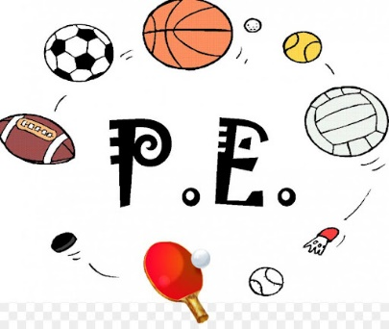  - to pass the ball with accuracy.  - to cross over the ball.  - to cooperate in a group.  - to dribble the ball in a range of situations.  - to make decisions on how to be successful as a group.  - to shoot the ball.  - to perform a combination of skills before shooting the ball.  SPORTSHALL ATHLETICS  Children will be taught:  - try to improve reaction speed through repetition  - to use elements of the correct technique for the underarm throw  - to demonstrate elements of an effective sprinting technique  - to know how to pass and receive a baton using the down sweep  - to demonstrate a degree of endurance and stamina to be able to run for longer distances  - to understand how to pace themselves and can sometimes do this in a race  - to sometimes use their preferred leg to lead with over the obstacles  - to demonstrate some elements of the different jumping technique  - to use different throwing techniques for distance and accuracy.
PSHE | FAMILY AND FRIENDS  What is friendship and how will friendships change over time?  - to have strategies for managing some of the pressures in relationships.  - to know how to get support from people they trust and how they can support other people.  - to be able to identify the special people in their networks and to recognise how their networks have changed and developed.  - to have developed ways of beginning new friendships and of maintaining existing ones during times of change.  - to recognise and value differences between people and how that can be a positive aspect of their friendships.  - to understand the importance of groups within friendships and recognise some of the pressures which can occur in group situations.  - to know how to get support from people they trust and how they can support other people.  DIVERSITY AND COMMUNITIES  What are the nationalities, cultures and ethnic groups in my local area?  - be able to recognise aspects of their identity and understand how other people can influence their perception of themselves  - be able to describe the ethnic make up of their community and different groups that live in Britain.  - recognise the negative effects of stereotyping and prejudice.  - know about how they and others, including volunteers, contribute to the community.  - understand about the role of the media and its possible influences.  - understand some ways of caring for the environment and the contribution they can make.
RE | WHAT MATTERS MOST TO HUMANISTS AND CHRISTIANS?  Children will be taught:  - Your values are what you see as important and serve as guiding principles in your life.  - Humanism is a philosophy or a way of thinking about the world.  - Humanism is a set of ethics or ideas about how people should live and act.  - Humanist teaching stresses the importance of ‘living a good life’.  - The Golden rule – treat others the way you would like to be treated is shared by Humanism and Christians.  - Your worldview is your ideas about life; the foundation that your beliefs, actions, decisions and opinions are based on.  - Your influences affect your worldview.  - The Ten Commandments are a fundamental set of rules for Christians and Jews.  - The Fall: Christians believe when Adam and Eve disobeyed God, they 'fell' from perfection and brought evil into a perfect world.  - A dilemma is a difficult situation where you have to make a choice.
ICT

OTHER INFORMATION | Children should read to an adult at least three times every week. This should then be recorded in the reading record. Children who have read three times during a week will then receive a token and a raffle ticket. The tokens go towards helping the class to try and win a film afternoon and the raffle tickets are chances to win a prize.  Homework is given out on a Friday to be returned by the following Tuesday. It will always consist of spellings (on which there is a weekly test), maths and reading comprehension. Please do not return the sheets due to current regulations. Evidence of homework can be put on Dojo by taking a photograph of it. If you need any help with the homework please feel free to contact the teacher through Dojo.  PE is on Wednesday and Thursday so children should come to school on these days in their PE kit.  Children are encouraged to bring water bottles to school as research shows that keeping well hydrated leads to better learning outcomes. Please send them each day with a named bottle.

