YEAR 6 CURRICULUM NEWSLETTER
AUTUMN 2
Welcome to the Year 6 newsletter for the second half of the Autumn term. As always this is a busy term at school. Children will be receiving regular homework and will be expected to read to an adult at home at least 3 times a week.

SECONDARY TRANSFER | 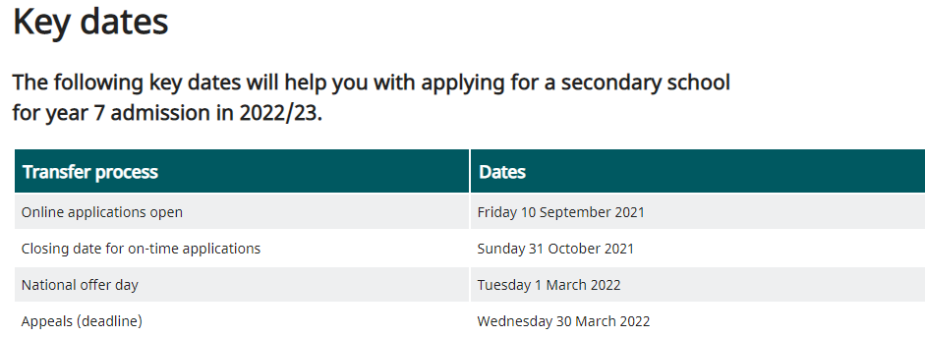  Applying for your child’s secondary school is something that you MUST do before the end of October. We would recommend that you look at local school’s websites and attend any open days/evenings that are running either in person or virtually. That way you will be able to make a considered decision. If you need any help or advice, then please do contact us.  Follow the link below for further information about how to apply:  https://www.leicester.gov.uk/schools-and-learning/school-and-colleges/school-admissions/starting-secondary-school/
SATs | These will take place between Monday 9th and Thursday 12th May 2022. The children will have 6 tests:  - Reading  - Grammar and punctuation  - Spelling  - Maths – Arithmetic (calculations)  - Maths – Reasoning x 2 papers (word problems)  Please ensure that you do not book appointments during these dates. We will be distributing the books that you have ordered to support SATs once they arrive after half term.
ENGLISH | This half term the children will write:  - An informal letter as an evacuee child  - A formal letter to the residents of a village  - A newspaper report linked to World War Two topic  - A narrative based on Macbeth  - A letter to Santa trying to persuade him to buy something  Our class books will be continuing:  - Friend of Foe, Michael Morpurgo  - Letters from the Lighthouse, Emma Carroll  In pieces of writing the children will:  - Plan their writing by:  - identifying the audience for and purpose of the writing (knowing who the reader is)  - noting and developing initial ideas, drawing on reading and research where necessary  - in writing narratives, considering how authors have developed characters and settings in what pupils have read, listened to or seen performed  - Draft and write by:  - selecting appropriate grammar and vocabulary  - in narratives, describing settings, characters and atmosphere and integrating dialogue to convey character and advance the action  - using a wide range of devices to build cohesion within and across paragraphs  Cohesion needs to be achieved in a sentence, within a paragraph and across paragraphs for a text to make sense. Cohesion can be achieved by using: adverbials, punctuation, repetition, pronouns, synonyms and a variety of conjunctions.  - using further organisational and presentational devices to structure text and to guide the reader [for example, headings, bullet points, underlining]  - Evaluate and edit by:  - reading their own and other children’s writing and making edits.  - proposing changes to vocabulary, grammar and punctuation to enhance effects and clarify meaning  - ensuring the consistent and correct use of tense throughout a piece of writing  - ensuring correct subject and verb agreement when using singular and plural, distinguishing between the language of speech and writing and choosing the appropriate register  - proof-read for spelling and punctuation errors
MATHS | FOUR OPERATIONS (addition, subtraction, multiplication and division) This will continue after half term.  - multiply numbers by a one-digit number using long multiplication  - solve reasoning questions using the formal method of long multiplication  - divide numbers by a two-digit number using long division  - solve one-step division problems, rounding the answer depending on the context  - divide four-digit numbers by a two-digit number using short division without remainders  - perform one-step mental calculations with increasingly large numbers  - solve reasoning questions involving mental addition, subtraction, multiplication and division  - add and subtract whole numbers using a formal written method  - correctly use the order of operations to carry out calculations  - explore the order of operations using brackets  - find missing numbers using the inverse  - select the correct operation/s to use and solve a problem, checking the answer using estimation  - solve one-step problems and check their answer using estimation  - round numbers to a specified degree of accuracy  - use rounding to check answers to problems  - sort one-step problems in a sorting diagram  - solve two-step problems involving addition and subtraction.  FRACTIONS  - simplify fractions  - compare and order fractions related to a half and also by making the denominators the same  - add and subtract fractions with different denominators, including mixed numbers.  - multiply and divide fractions  - divide fractions by whole numbers
SCIENCE | ELECTRICITY  Pupils will be taught to:  - associate the brightness of a lamp or the volume of a buzzer with the number and voltage of cells used in the circuit  - compare and give reasons for variations in how components function, including the brightness of bulbs, the loudness of buzzers and the on/off position of switches  - use recognised symbols when representing a simple circuit in a diagram.  Building on their work in year 4, pupils will construct simple series circuits, to help them to answer questions about what happens when they try different components, for example, switches, bulbs, buzzers and motors. They should learn how to represent a simple circuit in a diagram using recognised symbols.  Pupils will be taught to take the necessary precautions for working safely with electricity. Pupils might work scientifically by: systematically identifying the effect of changing one component at a time in a circuit; designing and making a set of traffic lights, a burglar alarm or some other useful circuit.
DT | HAND STEADY GAME  The children will make a Christmas themed hand steady game. They will Identify the components within a hand steady game; Create a circuit diagram; Write success criteria for a successful game; Make a Hand steady game and Evaluate and review the game and process.
PE | SPORTSHALL ATHLETICS  Children will be taught:  - try to improve reaction speed through repetition  - to use elements of the correct technique for the underarm throw  - to demonstrate elements of an effective sprinting technique  - to know how to pass and receive a baton using the down sweep  - to demonstrate a degree of endurance and stamina to be able to run for longer distances  - to understand how to pace themselves and can sometimes do this in a race  - to sometimes use their preferred leg to lead with over the obstacles  - to demonstrate some elements of the different jumping technique  - to use different throwing techniques for distance and accuracy.  TEAM BUILDING  - to be able to work cooperatively with a partner.  - to be able to work cooperatively as part of a team.  - to be able to communicate within the group.  - to be able to communicate to make decisions.  - to be able to give clear instructions to others in your group.  - to be able to decide on a strategy to complete the challenge.  - to be able to communicate as part of a team.
PSHE | DIVERSITY AND COMMUNITIES  What are the nationalities, cultures and ethnic groups in my local area?  - be able to recognise aspects of their identity and understand how other people can influence their perception of themselves  - be able to describe the ethnic make up of their community and different groups that live in Britain.  - recognise the negative effects of stereotyping and prejudice.  - know about how they and others, including volunteers, contribute to the community.  - understand about the role of the media and its possible influences.  - understand some ways of caring for the environment and the contribution they can make.  SEX AND RELATIONSHIPS  What will happen to my body as I grow up and how can I care for it?  - know and understand the appropriate use of the scientific names for the external and internal sexual parts of the body, and be able to explain basic functions.  - understand the importance of washing regularly and of maintaining other hygiene routines during puberty.  - understand ways they can prevent the spread of some bacterial and viral diseases.  - understand the main changes that will happen at puberty, know some ways to manage them, and how it affects people differently.  - have a basic understanding about body image, and have learnt some ways to support a positive body image for themselves and others.  - Some of the changes during puberty will include: breasts begin to grow, hair gets greasy, sperm starts to be produced, hair starts to grow on your face, the body changes shape, periods start.  - A woman’s menstrual cycle is approximately 28 days (1 month).  - There are a variety of menstrual products including: tampons, pads and recyclable products such as menstrual cups.
RE | HOW IS THE NATIVITY STORY INTERPRETED  In this unit the children will look at The Christmas Story in depth and will be encouraged to look for differences and similarities in the two accounts within the Bible. The children will also investigate traditions associated with celebrating Christmas both here and around the world.
ICT | NETWORKS  The aim of these sessions is to provide children with the opportunity to find out more about how networks work, understand computer networks including the internet, learn how they can provide multiple services, such as the World Wide Web, and explore the opportunities they offer for communication and collaboration. We will discover what the children know about the internet and do some research and find out about the age of the internet. The children will find out what a LAN and a WAN are and think about how we access the internet in school. Finally, we will think about what the future might hold for the internet and technology.  BLOGGING  This unit of work uses the Purple Mash tool 2Blog and is designed to help children learn the basic principles of creating and maintaining a blog in a controlled and safe environment. Using 2Blog, this unit will give the children a basic. understanding that blogs need to be maintained regularly and how the approval process of comments works. They will also demonstrate awareness of issues surrounding inappropriate posts and cyberbullying.
OTHER INFORMATION | Children should read to an adult at least three times every week. This should then be recorded in the reading record. Children who have read three times during a week will then receive a token and a raffle ticket. The tokens go towards helping the class to try and win a film afternoon and the raffle tickets are chances to win a prize.  Homework is given out on a Friday to be returned by the following Tuesday. It will always consist of spellings (on which there is a weekly test), maths and reading comprehension. Please do not return the sheets due to current regulations. Evidence of homework can be put on Dojo by taking a photograph of it. If you need any help with the homework please feel free to contact the teacher through Dojo.  Children are encouraged to bring water bottles to school as research shows that keeping well hydrated leads to better learning outcomes. Please send them each day with a named bottle.

