YEAR 6 CURRICULUM NEWSLETTER
SUMMER 1
Welcome to the Year 6 newsletter for the first half of the Summer term. This term is set to be very busy as we continue to prepare the children for their transition from primary to secondary school, ensuring they are ready for the requirements of Year 7.
SATs | We have decided that so that the children have the opportunity to showcase what they have learnt at primary school we will be completing some SATs tests. These will be completed internally and the data will be used for internal tracking and to identify gaps in learning that we can pass to the secondary schools. Whilst they will be under test conditions we will make it as pleasurable experience as we can and it is really nothing for the children to worry about.  We will be completing these in the week beginning 17th May.
ENGLISH | This half term the children will write:  - An explanatory text  - A short story – based on a poem  - A leaflet about healthy living  Our class books will be continuing:  - Flotsam  - The Visitor by Ian Serraillier  - Assorted health information  In pieces of writing the children will:  - Plan their writing by:  - identifying the audience for and purpose of the writing (knowing who the reader is)  - noting and developing initial ideas, drawing on reading and research where necessary  - in writing narratives, considering how authors have developed characters and settings in what pupils have read, listened to or seen performed  - Draft and write by:  - selecting appropriate grammar and vocabulary  - in narratives, describing settings, characters and atmosphere and integrating dialogue to convey character and advance the action  - using a wide range of devices to build cohesion within and across paragraphs  Cohesion needs to be achieved in a sentence, within a paragraph and across paragraphs for a text to make sense. Cohesion can be achieved by using: adverbials, punctuation, repetition, pronouns, synonyms and a variety of conjunctions.  - using further organisational and presentational devices to structure text and to guide the reader [for example, headings, bullet points, underlining]  - Evaluate and edit by:  - reading their own and other children’s writing and making edits.  - proposing changes to vocabulary, grammar and punctuation to enhance effects and clarify meaning  - ensuring the consistent and correct use of tense throughout a piece of writing  - ensuring correct subject and verb agreement when using singular and plural, distinguishing between the language of speech and writing and choosing the appropriate register  - proof-read for spelling and punctuation errors
MATHS | PERIMETER, AREA AND VOLUME  Much of this block is new learning where children build on their knowledge of area and perimeter to explore the area of a triangles and parallelograms. The recap step on volume covers the difference between volume and capacity and gives time to explore the conservation of volume using centimetre cubes.  RATIO  - Using ratio language  - Ratio and fractions  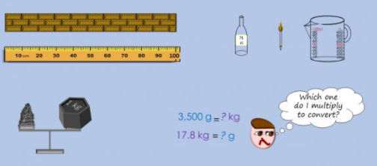  - Introducing the ratio symbol  - Calculating ratio  - Using scale factors  - Calculating scale factors  - Ratio and proportion problems  CONVERTING UNITS OF MEASURE  - Metric measures  - Convert metric measures  - Calculate with metric measures  - Miles and kilometres  - Imperial measures
SCIENCE | 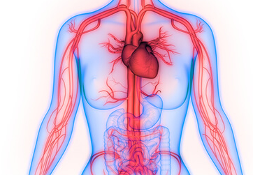  THE CIRCULATORY SYSTEM  - identify and name the main parts of the human circulatory system, and describe the functions of the heart, blood vessels and blood  - recognise the impact of diet, exercise, drugs and lifestyle on the way their bodies function  - describe the ways in which nutrients and water are transported within animals, including humans
GEOGRAPHY | NORTH AMERICA  - To locate North America on a map and name/locate some of the main countries.  - To identify the main environmental regions in these countries.  - To identify key physical and human characteristics and some major cities in these countries.  - To use latitude and longitude to describe where places in North America are.  - To identify the different time zones in North America.  - To understand geographical similarities and differences through the study of North America and UK.  - To describe the climate of North America.  - To describe the physical and human geography of parts of North America.
DT | 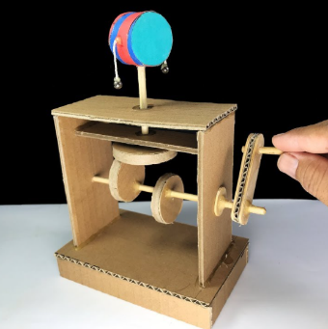  Mechanical systems: Automata toys  Linked with our English unit based around the book ‘Flotsam’, the children will construct a prototype of their plastic removing machine using an automata mechanism; measuring and cutting their materials, assembling the frame, choosing cams, designing the parts that sit on the followers and also finishing with a foreground and background.
ART | 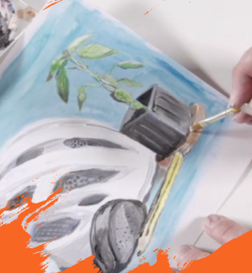  Year 6 Art and design: Still life  In this topic, pupils revisit their still life skills, creating a variety of pieces influenced by different artists and using a range of mediums. They use charcoal, erasers and paint to depict their chosen composition of chosen objects before displaying them to showcase their work.
SPELLING | We will be revisiting many of the spelling patterns and rules that have been covered throughout their time at school. This will ensure they are able to proof read and edit their own work more effectively.
PE | TEAM BUILDING  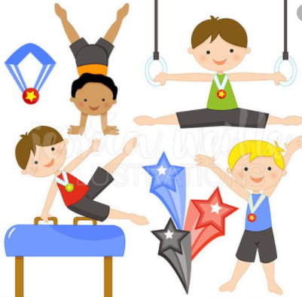  In this unit the children will use simple maps to orientate and take part in problem solving and team challenges giving their ideas and opinions. They will listen and give constructive feedback to other children’s ideas as well as compare their performances with previous ones and demonstrate improvement to achieve their personal best, through Teacher feedback and support and through peer assessment and discussion.  GYMNASTICS  - Create sequences on their own or with a partner that are flowing, fluent and expressive.  - Be given a theme and produce their own complex and extended sequence.  - Use cannon, unison, counter balance and counter tension in their sequences.  - Perform rolls with accuracy and flair.  - Perform ¼, ½ and full turns with accuracy from apparatus.  - Perform shaped jumps from apparatus with good body control and flair.  - Move and use equipment safely and set up their own activity stations.  - Use equipment e.g. ribbons or balls in a sequence.  - Hold shapes that are strong, fluent and expressive.  - Can vault using a springboard onto or over a piece of apparatus with teacher support.  - Use apparatus safely and imaginatively
PSHE | SEX AND RELATIONSHIPS  YEAR 5 concepts that they missed last year  - know and understand the appropriate use of the scientific names for the external and internal sexual parts of the body, and be able to explain basic functions  - understand the main changes that will happen at puberty, know some ways to manage them, and how it affects people differently  - have a basic understanding about body image, and have learnt some ways to support a positive body image for themselves and others  - understand the importance of washing regularly and of maintaining other hygiene routines during puberty  - understand ways they can prevent the spread of common diseases, and have a rudimentary understanding of HIV  YEAR 6 concepts  - be able to describe the main stages of how a baby is made, using some scientific vocabulary  - be able to describe some emotions associated with the onset of puberty and have strategies to deal with these positively  - understand that puberty affects people in different ways both physically and emotionally  - understand that the way they behave affects others and that they have some responsibility to others to make sure they are not hurt needlessly  - describe some characteristics of a loving trusting relationship  - understand some basic reasons why a couple might choose to have children  - show awareness of some family arrangements which are different from theirs
ICT | We will be focussing on ICT in Summer 2 with more extended units of work.
RE | Children will explore the definition of and popular ideas relating to the concept of eternity. They will compare concepts of eternity from both religious and non-religious worldviews.  Children will be able to:  - understand and use key vocabulary related to the concept of eternity;  - distinguish between the ideas of mortality and immortality;  - relate this to the human life cycle.
OTHER INFORMATION | Children should read to an adult at least three times every week. This should then be recorded in the reading record. Children who have read three times during a week will then receive a token and a raffle ticket. The tokens go towards helping the class to try and win a film afternoon and the raffle tickets are chances to win a prize.  Homework will be uploaded to do jo on a Friday to be returned the following Tuesday. It will always consist of spellings (on which there is a weekly test), maths and reading comprehension. Evidence of homework can be put on Dojo by taking a photograph of it. If you need any help with the homework please feel free to contact the teacher through Dojo.  PE is on Monday and Thursday so children should come to school on these days in their PE kit.  Children are encouraged to bring water bottles to school as research shows that keeping well hydrated leads to better learning outcomes. Please send them each day with a named bottle.

