LANGUAGE DEVELOPMENT IN SRE
In each case the list of words is cumulative i.e. the word penis is included in the foundation stage list: it should be used in all following lists.
YEAR GROUP | KEY AREAS OF LEARNING | FEELINGS AND RELATIONSHIPS | BODY PARTS AND PROCESSES | OTHER
FOUNDATION STAGE | External body parts | Range of feelings words e.g. happy, pleased, calm, sad  baby  child  girl  boy | size  shape  range of simple external body parts e.g. hands, head, teeth  penis  testicles  vulva  vagina bottom | range of action words e.g. run, jump  growing up germs
YEAR 1 AND 2 | External body parts | same  similar  different  unique  special responsibility | birth  death  range of more specific external body parts e.g. stomach, chest | male  female  man  woman teenager  adult
YEAR 3 AND 4 | External body parts  Differences between male and female | love dependent independent | breast nipple anus scrotum | toiletries bacteria infection hygiene
YEAR 5 AND 6 | Puberty  Sexual reproduction  Internal body parts | commitment marriage  stable relationship | puberty development period menstruation cervix  labia  fallopian tube clitoris  ovary  ovum  vulva  vagina  uterus  ovulation  sperm  sperm duct seminal vesicle urethra  pubic hair  voice breaking arousal  erection  sexual intercourse sex  ejaculate conception pregnancy | sanitary towel tampon body odour deodorant

What do the words mean?
These explanations, definitions and diagrams are intended for the use of adults in school, to confirm understanding. They are not intended for direct use with children.
The female sexual parts
The diagrams below are courtesy of www.macmillan.org.uk ; for additional 3D diagrams of the female sexual parts visit www.3Dvulva.com
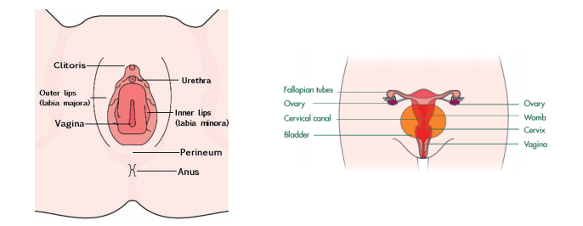
Breasts - In females, the breasts are primarily for feeding babies. The fatty deposits protect the glands that produce breast milk, which is the healthiest first food for a baby. They are sensitive to touch. The nipple is the end point of the breast and all the milk producing tubes end up at the nipple.
Cervix - This is the structure which forms the neck of the womb. It is a muscular ring which opens and closes especially during birth. During pregnancy it holds very tightly shut to keep the baby safe in the uterus.
Clitoris - The clitoris is a small pea shaped bump and joining point of the inner labia. It is highly sensitive to touch and is associated with sexual pleasure in females. It has between 6, 000 and 8,000 sensory nerve endings, which is more than any other organ in the human body including the penis and the testicles.
Fallopian tube - There are two fallopian tubes. Each one connects an ovary to the womb. This is the tube down which the egg travels from the ovary.
Labia - This word means lips. The labia are folds of skin which protect the opening to the vagina. They enlarge during puberty. There are both inner and outer labia as shown in the left hand diagram.
Ovary - There are two ovaries in each female reproductive system. They release eggs into the fallopian tubes, which in turn guide the eggs into the womb. Ovulation is the process of releasing an egg from the ovary.
Ovum - (ova-plural, ovum-singular). The ovum, or egg, is an amazing structure and can live for up to 24 hours. The egg is the largest cell in the human body and is much bigger and heavier than sperm. Even though a woman is born with between 1-2 million eggs, she’ll only release about 400 in her lifetime. Sometimes a woman releases a second egg when she ovulates, but it’s always within 24 hours of the first.
Perineum - This is the skin between the opening of the vagina and the anus. It can tear during child birth.
Urethra - This tube, found in both males and females carries urine from the bladder out of the body. The opening of the tube does not have a different name and is also called the urethra.
Uterus - This is the organ of the female body where the fertilised egg begins to grow. It is the place where the foetus grows and develops through out a pregnancy.
Vagina - The vagina is also called the birth canal. Technically it is an internal structure. However the term is commonly used to refer to the external sex organs of females.
Vulva - The vulva is the correct term for the parts of female genitalia that can be seen from the outside. It includes the labia (lips), clitoris and the vaginal opening. The urethra (wee tube) is in this area as well, but is not technically part of the vulva. This vulva is often commonly (but incorrectly) called the vagina. Womb - See Uterus
The Male Sexual Parts
The diagram below is courtesy of www.macmillan.org.uk
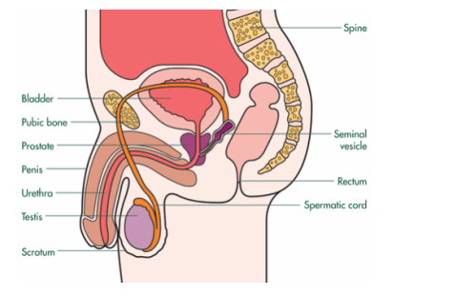
Ejaculation - This is the contraction of muscles in the penis which pushes semen from the testes and out of the penis. In each ejaculation there are approximately 300 million sperm contained in 2-5ml of semen. The sperm travel at about 10 miles per hour.
Penis - The penis performs two functions in males. It passes urine through the urethra from the bladder. The penis is the main sexual organ and sperm is passed through the urethra during ejaculation. The body of the penis consists of blood vessels which fill with blood when the man is aroused. This forms an erection.
Scrotum - This is the pouch of skin which holds the testicles. During puberty the scrotum enlarges so that the testes hang away from the body where it is the right temperature for sperm production. When the testes are exposed to cold the scrotum contracts and moves the testes closer to the body.
Semen - The whitish fluid that carries sperm and is ejaculated from the body during an orgasm.
Seminal vesicle - This is the small sack which contains a liquid which is added to sperm to make semen.
Sperm - This is the male reproductive cell which is capable of fertilising an egg. It is carried in semen into the female uterus following ejaculation. Sperm can live with in the female body for up to 7 days after ejaculation. Really healthy sperm can travel up to 19cm an hour, once inside the female body, although the average is closer to 9cm an hour. There are 1,500 sperm in a dot the size of a full stop.
Sperm duct (spermatic cord) - These long tubes connect each testicle to the seminal vesicle, so the sperm can pass along.
Testicle /Testis (testis-singular, testes-plural) - The male reproductive organ where sperm is produced. Once sperm is produced it is stored in the testicles for 2-3 weeks. If it not used (ejaculated), it is reabsorbed into the body, ensuring a fresh supply of sperm. During puberty the testes drop away from body so that the testes can maintain a temperature lower than body temperature. The terms ‘testicles’ and ‘testes’ are essentially interchangeable.
Urethra - This tube, found in both males and females, carries urine from the bladder out of the body. In the male, it also carries semen.

