English  We use these stories for the basis of our writing – writing letters, stories, postcards, poems and diaries.  Autumn Term: Lion and the Meadow, Stuck, Zog, Lila and the Secret of Rain, The Jolly Postman and books by Anthony Browne.  Spring Term. Toby and the Great Fire of London, Owl and the Pussycat Poetry, Bear and the Piano and The Lighthouse Keeper’s Lunch.  Summer Term Pandora’s Box, Storm Whale, Magic Box Poem, Tin Forest and Shakespeare. | Maths – Singapore Maths  Autumn Term  Place Value, Addition and Subtraction, Multiplication and Division and Shape  Spring Term  Fractions, Time, Money, Data, Mass and Temperature  Summer Term  Word problems and Volume. | Science  Autumn Term  Animals including humans  Looking after the environment  Spring Term  Plants  Living things and their habitats  Summer Term  Lifecycles  Use of everyday materials | History and Geography Topics  Autumn Term  Great Explorers  Comparing the UK to another country  Spring Term  United Kingdom  Great fire of London  Summer Term  Thomas Cook  Hot and Cold Places
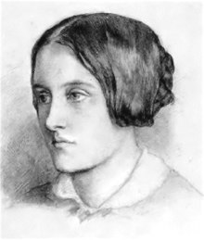
Year 2
Curriculum Overview
ICT  Autumn Term  E-safety, Coding and spreadsheets  Spring Term  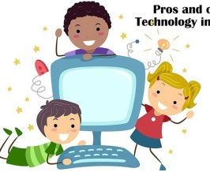  E-safety, making music, research  Summer Term  E-safety  Creating pictures using different technology | Music  Sound scapes  Learning about pitch and volume | Design and Technology  Autumn Term  Mechanics and Christmas cards  Spring Term  Sculptures  Summer Term  Textiles | Art  Autumn Term  Formal Elements of Art  Spring Term  Art Appreciation  Summer Term  Mixed Media
R.E  Autumn Term  Who is a Hindu and what do they believe?  Where do I belong, what do I believe?  Spring Term  What do Muslims believe in?  Summer Term  Inspiring people, what can stories teach us about life?  Meaning of symbols | French  After half term we will be learning:  - Simple greetings  -Numbers  - Colours | P.E  Autumn Term- Sending and receiving, kimbles, dance  Spring Term- Gymnastics, Curling, Outdoor education  Summer Term- Swimming and athletics. | P.S.H.E  Autumn Term  Friendship and famiy  Spring Term  Energy saving and the environment  Summer Term  Inspirational people

