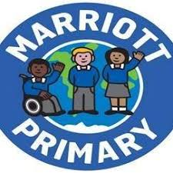

* In PSHCE, we will be focussing on Keeping Healthy.
* In RE, we are looking at the deeper meanings of celebrations in religions
* We will be learning about the Blues genre of music and looking at the 12 bar blues.
* Science –States of Matter
* Geography – Counties & the East Midlands
* D&T – Design and make a Diva lamp and making a pouch for Christmas
* Computing –Writing for different audiences & Using coding instructions
* We are learning about who is in our family in French and vocabulary linking to Christmas.
* Our novel focus this term is **Charlotte’s Web.**
* During this topic, we will be focusing on writing in paragraphs, including speech in our writing and how to write persuasively.
* We will be focusing on multiplication and division of single digit numbers. We will learn how to multiply and divide larger numbers too.
* There will be a weekly times table test as well.
* We are doing dance, looking at linking movements together and working on our Speed, Agility and Quickness.

**Mathematics**

**English**

**Year 4** *Autumn 2 - 2020/21*

**Half Term Curriculum Overview**

**Science, History, Geography, Art, D&T and Computing**

**Homework**

**Music**

**French**

**Physical Education**

**PSHCE and RE**

* **English/Maths:**Homework is set to consolidate skills taught in class. Sheets will be sent out on a Friday. Please post your work on your portfolio on Dojo.
* **Spellings:** A test each week and new spellings to be learnt given out on a Friday.
* **Reading:** Books are changed on a Friday. Please practise your reading regularly.