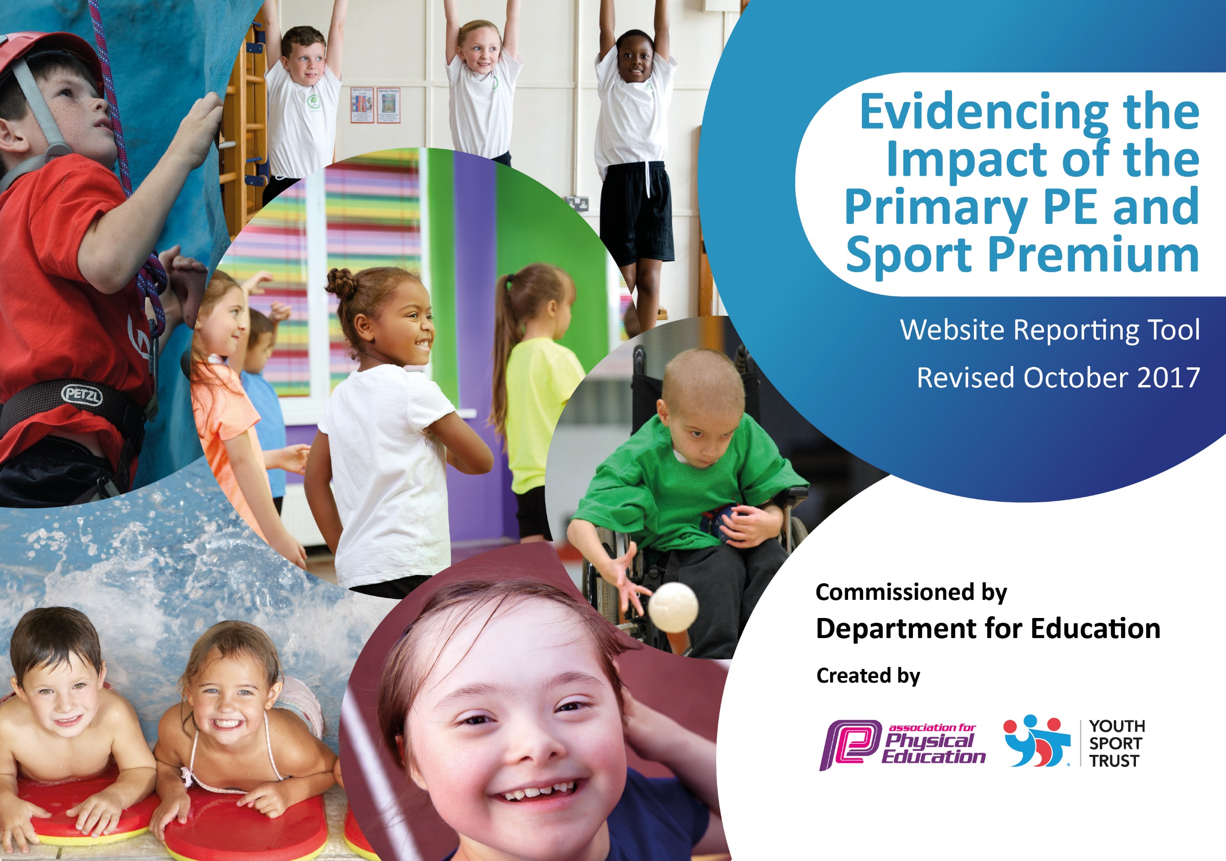

Schools must use the funding to make additional and sustainable improvements to the quality of PE and sport they offer. This means that you should use the Primary PE and Sport Premium to:

- develop or add to the PE and sport activities that your school already offers
- build capacity and capability within the school to ensure that improvements made now will benefit pupils joining the school in future years

Please visit gov.uk for the revised DfE guidance including the 5 key indicators across which schools should demonstrate an improvement. This document will help you to review your provision and to report your spend. DfE encourages schools to use this template as an effective way of meeting the reporting requirements of the Primary PE and Sport Premium.

We recommend you start by reflecting on the impact of current provision and reviewing the previous spend.
Under the Ofsted Schools Inspection Framework, inspectors will assess how effectively leaders use
the Primary PE and Sport Premium and measure its impact on outcomes for pupils, and how effectively governors hold them to account
for this.

Schools are required to publish details of how they spend this funding as well as on the impact it has on pupils’ PE
and sport participation and attainment.
We recommend regularly updating the table and
publishing it on your website as evidence
of your ongoing review into how you are using the money
to secure maximum, sustainable impact. To see an example of how to complete the table please click HERE.

Support for review and reflection - considering the 5 key indicators from DfE, what development needs are a priority for your setting and your students now and why? Use the space below to reflect on previous spend, identify current need and priorities for the future.

Key achievements to date: 2016-2017 | Areas for further improvement and baseline evidence of need:
Achieving Sportsmark Gold.  Winning the Leicester City SSP Primary Sports Award.  Girls finished top of their division in the football league.  Boys reached the quarter finals of the FA Cup.  Third in the Sportshall Athletics Competition.  Aja first girl in the Year 4 X-Country in October and March.  Aja and Sophia both qualify for the County X-Country Finals.  Cohen third boy in the Parallel Sportshall Athletics Competition.  Y5/6 Girls Netball Team finished top of their league.  Riders Hoops for Health Competition – Ashanti voted Most Valuable Player.  Year 4 Tennis Team were third.  Year 3 Tennis Team were Spirit of the Games Winners.  Maja third place in the Y5/6 Gymnastics Competition.  Tag Rugby – Neron voted Most Valuable Player.  Table Tennis – girls were second and the boys were third.  Parallel X – Country Skye won gold, Scarlett Silver and Harley Bronze.  Athletics –Year 4 - Chukwuibike first in the 50m & second in the Howler, Aja first in the Howler and second in the 400m, Y4 girls relay team were second. Year 5 – Alex first in the 50m, James second in the 75m, Chaele first in the Howler, Y5 boys relay team were first. Year 6 – Ashanti third in the Long Jump. The school qualified for the Quadkids Finals. | Improve the quality of swimming being taught.  Swimming Evidence Folder maintained with changing groups.

Meeting national curriculum requirements for swimming and water safety | Please complete all of the below:
What percentage of your Year 6 pupils could swim competently, confidently and proficiently over a distance of at least 25 metres when they left your primary school at the end of last academic year? | 30%
What percentage of your Year 6 pupils could use a range of strokes effectively [for example, front crawl, backstroke and breaststroke] when they left your primary school at the end of last academic year? | 25%
What percentage of your Year 6 pupils could perform safe self-rescue in different water-based situations when they left your primary school at the end of last academic year? | 25%
Schools can choose to use the Primary PE and Sport Premium to provide additional provision for swimming but this must be for activity over and above the national curriculum requirements. Have you used it in this way? | Yes  £586 for an extra teacher  £380 for 2 staff to complete the ASA Level 1&2 Qualification.

Action Plan and Budget Tracking
Capture your intended annual spend against the 5 key indicators. Clarify the success criteria and evidence of impact that you intend to measure to evaluate for students today and for the future.

Academic Year: 2016/17 | Total fund allocated: £9,470 | Date Updated: December 2017
Key indicator 1: The engagement of all pupils in regular physical activity – Chief Medical Officer guidelines recommend that primary school children undertake at least 30 minutes of physical activity a day in school |  |  |  | Percentage of total allocation:
 |  |  |  | £2418.50
School focus with clarity on intended impact on pupils: | Actions to achieve: | Funding allocated: | Evidence and impact: | Sustainability and suggested next steps:
Introduce the Daily Mile – to improve the Health of students by increasing their activity by an extra 15 minutes.  Bikeability training for Year 6  Active lunchtimes for students.  House Competitions | Identify the course around the playground.  Encourage students to bike to and from school.  A range of activities for students to be involved in at lunchtime. Some competitions also taking place to engage students.  Skipping coach one lunchtime per week.  Competitions between the houses to increase participation | Table Tennis tables and equipment £1,100  Skipping Coach  £970  Basketball Posts  £348.50 | All pupils involved in an additional 15 minutes of exercise a day.  An increase in students bringing their bike to school.  Students involved in different activities at lunchtime e.g. Table Tennis, Skipping, Cricket, Netball etc.  Students involved in representing their house and participating in Level 1 Competitions  WIDER IMPACT  Pupils are more active in PE lessons and don’t try to stop and rest.  Improved standards in PE.  Attitudes to learning are improved.  SAT results improved. | Daily Mile embedded in the school day.  Encourage students in Y6 to be using their bikes to travel to and from school.  Continue to organise activities for students at lunchtime so that they can remain active.  Continue to organise Level 1Competitions throughout the year for students to be involved in.
Key indicator 2: The profile of PE and sport being raised across the school as a tool for whole school improvement |  |  |  | Percentage of total allocation:
 |  |  |  | £615
School focus with clarity on intended impact on pupils: | Actions to achieve: | Funding allocated: | Evidence and impact: | Sustainability and suggested next steps:
Celebration Assembly to ensure the whole school is aware of the importance of PE and Sport and to encourage and inspire students to be involved.  Noticeboards celebrating the success of our students and raising the profile of PE and School Sport.  Trophy Cabinet  Role Models visiting school or being met at events. | Achievement celebrated in Assembly, achievements, results, certificates etc presented.  Keep all of the displays up to date with the relevant information, competitions, trips, successes and progress.  Trophy Cabinet bought.  Invite local personalities into school or take students to events to watch and/or meet them. | £415  £200 | Pupils enjoy being involved in the Assembly and having their successes celebrated.  Noticeboard outside of main reception has an updated list of competitions and the results displayed for parents.  Noticeboards in the PE Corridor celebrate all of the events we have been involved in and the quality of PE being taught.  This encourages students to get involved and enjoy representing their school.  Trophy Cabinet displays the achievements of our students.  We have been to a variety of events where the students have met and been inspired including a cricket training session at Grace Road with the Pakistan Women’s Cricket Team, Watching Leicester Riders play then meeting the players afterwards, Eden Francis running sessions with students in school.  WIDER IMPACT  Pupils are proud to be involved in assemblies and have their achievements displayed on the noticeboards, school website and school twitter etc.  Increased self esteem/confidence has an impact on learning across the curriculum and when we attend events. | SLT see the benefits of the raised profile and continue their commitment to fund Primary PE and School Sport.  Continue to celebrate the amazing work that we are doing at Marriott.  Try to get a range of inspirational people in to school to talk to or work with children as well as attending events to inspire children.

Key indicator 3: Increased confidence, knowledge and skills of all staff in teaching PE and sport |  |  |  | Percentage of total allocation:
 |  |  |  | £9812
School focus with clarity on intended  impact on pupils: | Actions to achieve: | Funding  allocated: | Evidence and impact: | Sustainability and suggested  next steps:
School employs a specialist PE Teacher one day a week to work with the PE Co-coordinator and all of the staff in rotation throughout the year.  CPD provided for staff throughout the year by the PE Specialist or with Future Active or other outside agencies. | Use Staff questionnaire to identify areas of training required.  PE Teacher and class teachers to identify what activities will develop the staff knowledge.  Organise training sessions for staff in a variety of activities e.g. Kimbles, SAQ, Gymnastics, Swimming etc.  Book staff onto courses that are relevant to their development e.g. Swimming, HI5 Netball, Outdoor Education, Athletics Level 1 etc.  Staff to identify if they require cover to attend courses.  Purchase Safe Practice In PE Book | £8,963  CPD £430 + £380 Swimming  £39 | Improved knowledge for Teachers and Teaching Assistants, so they are more confident when teaching PE.  Increased confidence for running activities at lunchtimes and after school.  Subject Leader more confident when undertaking lesson observation, able to provide feedback and lead discussions.  PE Teacher confident to lead or organise the relevant training for staff.  WIDER IMPACT  Skills, knowledge and understanding of pupils are increased significantly.  Pupils enjoy PE and Sport, they are keen to participate, demonstrate and show a desire to learn and improve. | All staff will feel supported to be confident when delivering PE and Sport both within the Curriculum and School Sport.  Staff continue to be given CPD to further develop their knowledge in different activities.
Key indicator 4: Broader experience of a range of sports and activities offered to all pupils |  |  |  | Percentage of total allocation:
 |  |  |  | £3087.11
School focus with clarity on intended  impact on pupils: | Actions to achieve: | Funding  allocated: | Evidence and impact: | Sustainability and suggested  next steps:
Continue to offer a wide range of activities both within and outside the curriculum in order to get more pupils involved.  PE Curriculum which is varied to offer a variety of sports/activities to pupils.  Focus on girl’s involvement in sport.  Focus on those students who are sometimes reluctant to be involved in PE and Sport. | Arrange for external coaches to work with staff in lessons, clubs or Health Week.  Tri Golf  Cricket  Rugby  Dance  Kimbles  Tennis  Yoga  Skipping  Table Tennis  Run a club specifically for girls only and provide opportunities for girls only events.  Run a Change4 Life Club for students who do not always fully engage in PE and School Sport.  PE Equipment purchased.  Sport Team Kit purchased.  Hearing Impaired Students Specialist Hearing Piece for use in the swimming pool.  Hire an extra teacher for swimming. | £50  £160  £97.60  £200  £1876.06  £87.45  £30  £586 | A variety of extra-curricular clubs run throughout the year, these are run by Teachers and Teaching Assistants, staff are confident running these clubs.  WIDER IMPACT  Improved behaviour in school.  Students actively involved in PE lessons.  Students want to be involved in PE and School Sport.  Disaffected students engaged in PE and School Sport. | Staff work together and share good practice which develops confidence and staff more willing to support competitions and clubs.  Hope to expand the range of extra-curricular clubs.
Key indicator 5: Increased participation in competitive sport |  |  |  | Percentage of total allocation:
 |  |  |  | £1545
School focus with clarity on intended  impact on pupils: | Actions to achieve: | Funding  allocated: | Evidence and impact: | Sustainability and suggested  next steps:
Enter a variety of competitions and festivals through Leicester City SSPAN and local Leagues.  Focus on SEND to ensure they are involved in the competitions available to them. | Enter all of the competitions provided though Leicester City SSPAN including all of the SEND competitions.  Enter the Y5/6 boys Football League, Y5/6 girls Football League, Y3/4 Football League, FA Cup and County Cup.  Enter the Basketball League.  Enter the Hoops for Health Competition.  Participate in Central Venue competitions at CHCC.  Disability Athletics  Transport | £1,200  £300  £5  £40  £15  £4273.80 | We are involved in all of the competitions, we track all of the students who represent the school in these competitions.  We run Level 1 competitions so all student get to compete throughout the year.  Participation in competitions.  Level 1 – 100%  Level 2 – Y6 – 77%  Y5 – 82%  Y4 – 53%  Y3 – 55%  WIDER IMPACT  Improved standards in competition activities.  Girls engaged in Girl only and mixed competitions.  SEND involved in Disability competitions and other competitions. | More CPD for staff involved in running clubs.

