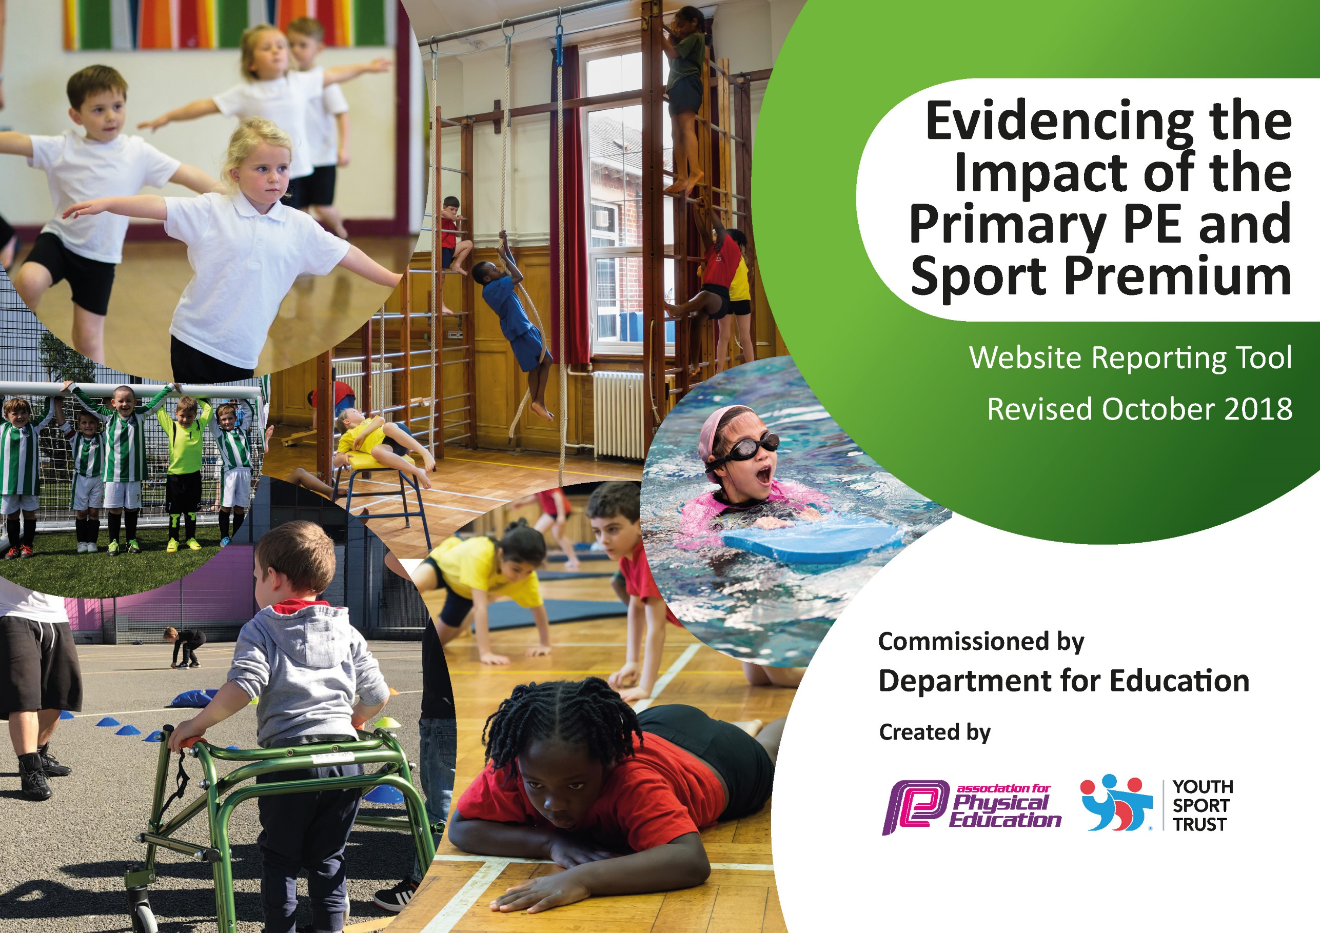
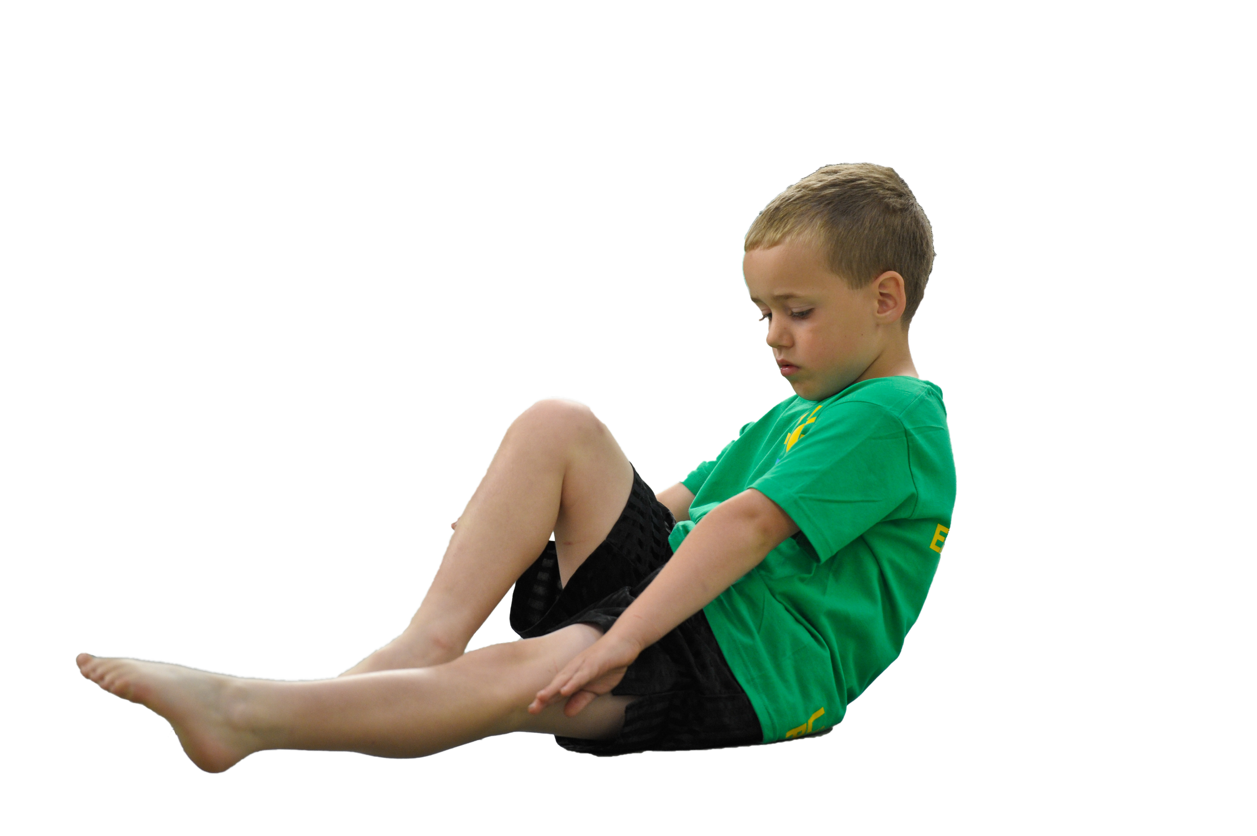
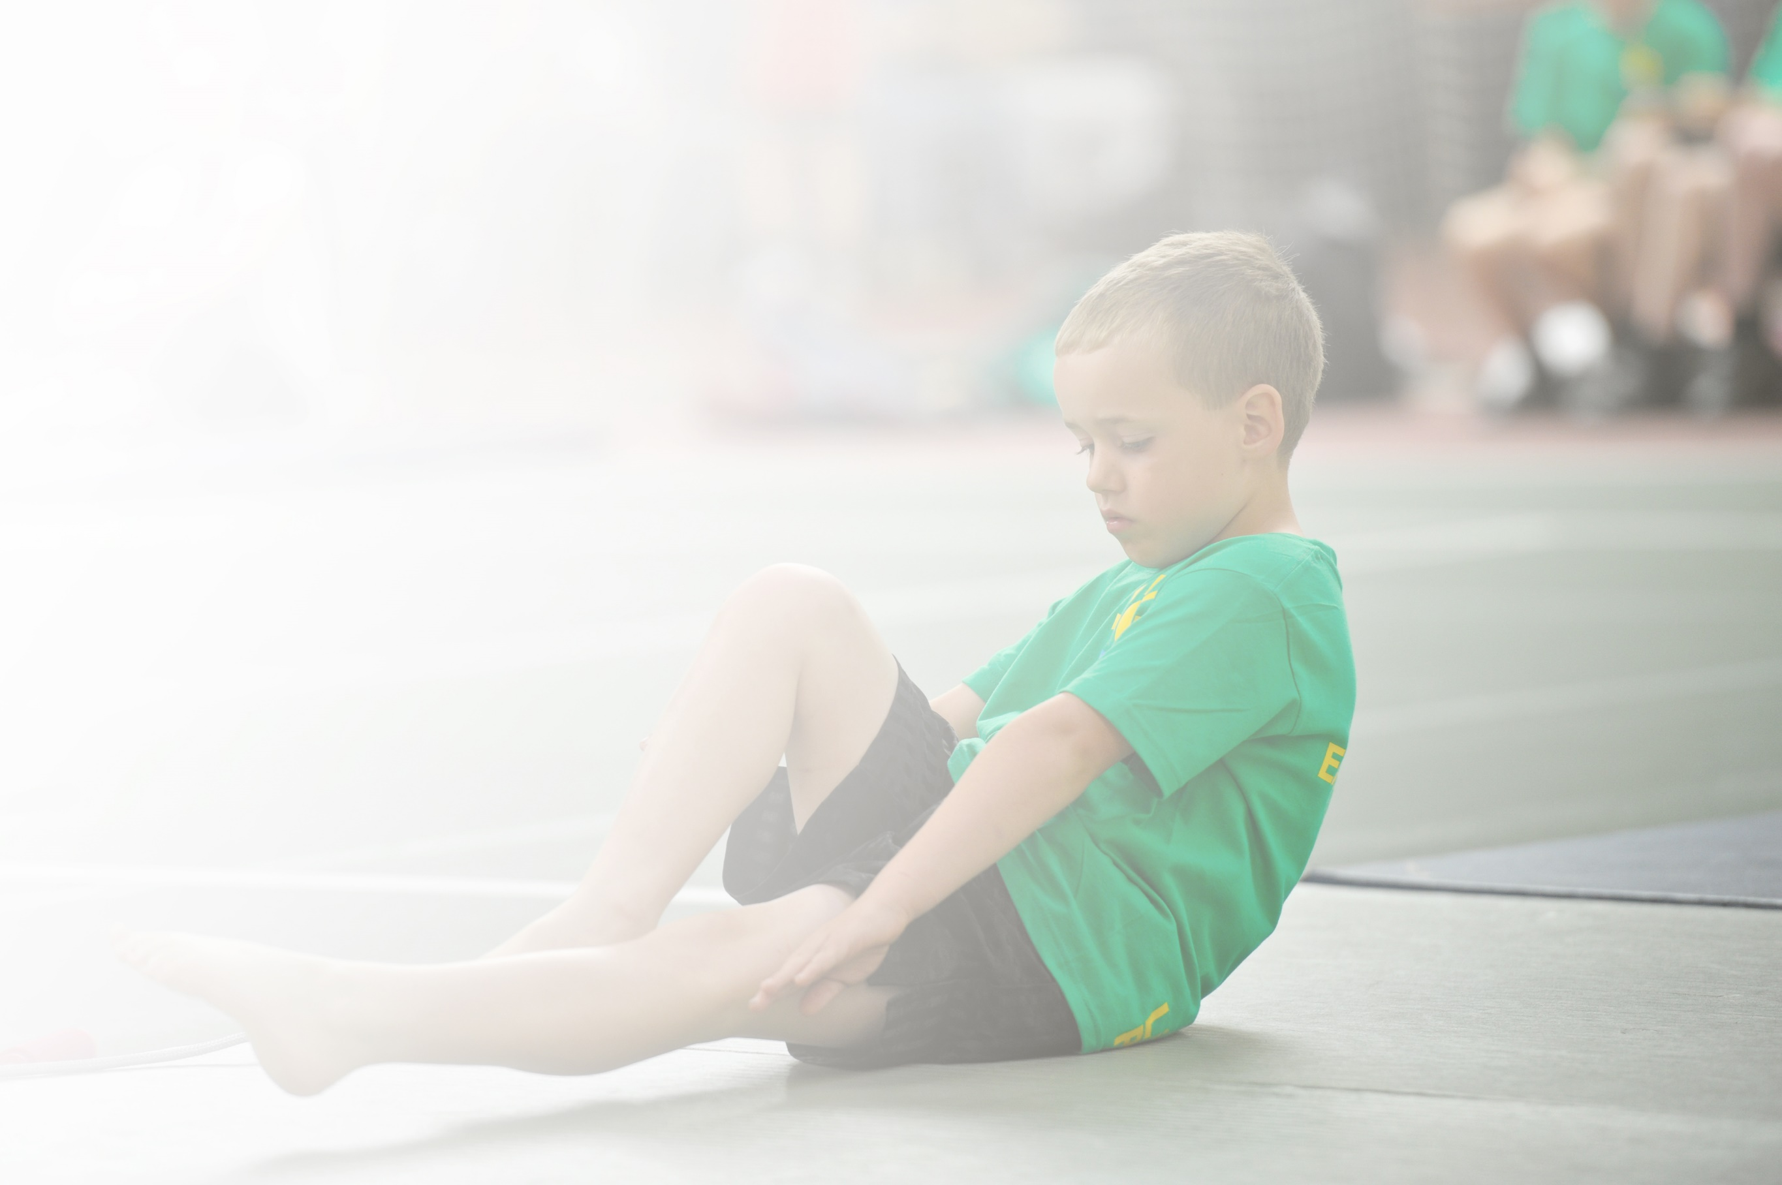
Schools must use the funding to make additional and sustainable improvements to the quality of Physical Education, Sport and Physical Activity (PESPA) they offer. This means that you should use the Primary PE and Sport Premium to:

- Develop or add to the PESPA activities that your school already offer
- Build capacity and capability within the school to ensure that improvements made now will benefit pupils joining the school in future years

Please visit gov.uk for the revised DfE guidance including the 5 key indicators across which schools should demonstrate an improvement. This document will help you to review your provision and to report
your spend. DfE encourages schools to use this template as an effective way of meeting the reporting requirements of the Primary PE and Sport Premium.

We recommend you start by reflecting on the impact of current provision and reviewing the previous
spend. Under the Ofsted Schools Inspection Framework, inspectors will assess how effectively leaders use the Primary PE and Sport Premium and measure its impact on outcomes for pupils, and how effectively governors hold them to account for this.

Schools are required to publish details of how they spend this funding as well as on the impact it has on pupils’ PE and sport participation and attainment by the end of the summer term or by 31 July 2019 at the
latest.
We recommend regularly updating the table and publishing it
on your website throughout the year, as evidence of your
ongoing review into how you are using the money to
secure maximum, sustainable impact. To see an
example of how to complete the table please
click HERE.

Support for review and reflection - considering the 5 key indicators from DfE, what development needs are a priority for your setting and your students now and why? Use the space below to reflect on previous spend, identify current need and priorities for the future.

Key achievements to date: | Areas for further improvement and baseline evidence of need:
- Achieving Sportsmark Gold for the 4th Year  - Sportshall Athletics Level 2 – Winners  - Level 3 Sportshall Athletics – Runners Up  - Disability Sportshall Athletics – Scarlett 2nd place girl.  - WOW Basketball Day  - X-Country October – Keston Y3 Boys Bronze, Aja Y5 Girls Gold  - X-Country March – Naledi Y3 Girls  - County & National X-Country Finals – 7 Qualifiers. Naledi 6th  - Table Tennis League – Boys & Girls Team 3rd. Aja 2nd Girl, Oliwier 3rd Boy  - Tennis – Team 3rd, Naledi – Best Female Player  - Gymnastics – Spirit of the Games Winners, KS1 Team – 3rd  - Girls Football – Won the Autumn League, Qualified for the Finals at LCFC  - Boys Football – Qualified for Division 1 in the Spring League  - Visit to Loughborough University to watch the Masters Wheelchair Tennis  - Boccia Level 2 – Winners  - Level 3 Boccia – 3rd  - Athletics – Chukwubuike Gold Y5 Boys 75m, Aja Gold Y5 Girls 600m & Howler, Chaele Gold Y6 Girls Howler, Alex Gold Y6 Boys 50m, Malachi Bronze Y6 Boys 75m, Y4 Girls Relay Silver, Y6 Boys Relay Silver  - Quadkids – 3rd, Aja 2nd Girl  - Girls Cricket – 3rd  - DSE National Disability Athletics Finals – Cohen 75m National Champion, Shot Silver. Mikhail Shot National Champion, 75m Silver  - Wildcats – Biggest club in the country.  - Visit form Rachel Pavlou – National Women’s Football Development Manager. | Assessment.  Staff to use sessions with PE specialist to help with their planning, make notes on the lesson, write them up so they have them for the future.

Meeting national curriculum requirements for swimming and water safety | Please complete all of the below:
What percentage of your current Year 6 cohort swim competently, confidently and proficiently over a distance of at least 25 metres?  N.B. Even though your children may swim in another year please report on their attainment on leaving  primary school. | 14%
What percentage of your current Year 6 cohort use a range of strokes effectively [for example, front crawl, backstroke and breaststroke]? | 14%
What percentage of your current Year 6 cohort perform safe self-rescue in different water-based situations? | 14%
Schools can choose to use the Primary PE and Sport Premium to provide additional provision for swimming but this must be for activity over and above the national curriculum requirements. Have you used it in this way? | Yes £525 for an extra teacher, so have smaller teaching groups.  £114 for a member of staff to complete the STA Level 2 Safety in Swimming Course.

Action Plan and Budget Tracking
Capture your intended annual spend against the 5 key indicators. Clarify the success criteria and evidence of impact that you intend to measure to evaluate for students today and for the future.

Academic Year: 2017/18 | Total fund allocated: £19,320 | Date Updated: January 2019
Key indicator 1: The engagement of all pupils in regular physical activity – Chief Medical Officer guidelines recommend that primary school children undertake at least 30 minutes of physical activity a day in school |  |  |  | Percentage of total allocation:
 |  |  |  | £670
School focus with clarity on intended impact on pupils: | Actions to achieve: | Funding allocated: | Evidence and impact: | Sustainability and suggested next steps:
KS2 - Daily Mile – to improve the Health of students by increasing their activity by an extra 15 minutes.  KS1 – Activate – students to complete an activate session each day.  Bikeability training for Year 6  Active lunchtimes for students.  Inter Class and Level 1 Competitions  Supermovers  Walk to School  Playground Leaders  Inclusive Football | Have different routes for the students to complete. Competition between the classes.  Teachers select different routines for the students to perform.  Encourage students to bike to and from school.  A range of activities for students to be involved in at lunchtime. Some competitions also taking place to encourage students.  Skipping every Tuesday lunchtime.  Competitions between the classes to increase participation.  Staff to choose areas which they want to work on with their class to get them active in the classroom e.g. 8 X Tables with Filbert Fox  Staff to record those students who are walking to school, so that they achieve their badges.  Y5 training at the start of the Academic Year. Teachers to put their student’s on rotation for each term.  Coach works in school delivering football to students who have SEND. | Skipping Coach  £320  Basketball Post  £350  Use PE Equipment  Photocopying Booklets | All pupils involved in an additional 15 minutes of exercise a day.  All pupils involved in an additional 15 minutes of exercise a day.  An increase in students bringing their bike to and from school.  Students involved in different activities at lunchtime e.g. Table Tennis, Skipping, Cricket, Netball, Basketball etc.  Students involved in representing their house and participating in Level 1 Competitions.  Students are active during lessons and use the routines to help learn different areas of the curriculum.  Students receiving their badges when they achieve targets.  Y5 Students are out in the KS1 Playground doing activities with the younger students.  All SEND student are involved in activity throughout the year.  WIDER IMPACT  Pupils are more active in PE lessons and do not try to stop as much and rest.  Improved standards in PE.  Attitudes to learning are improved.  SAT results improved.  Hit the target set by the Chief Medical Officer of being active for at least 30 minutes each day in school. | The Daily Mile embedded in the school day.  Activate embedded in the school day.  Encourage students in Y6 to be using their bikes to travel to and from school.  Continue to organise activities for students at lunchtime so they can remain active.  Continue to organise Level 1 competitions throughout the year for student’s to be involved in.  Staff to use the resource to support different areas of the curriculum, not the same routine all of the time.  Make sure records are kept of student’s achieving their rewards.  Set up each year with new Y5 classes.  At present, we get the coaching free, but may have to pay in the future if targeted funding is stopped.
Key indicator 2: The profile of PESSPA being raised across the school as a tool for whole school improvement |  |  |  | Percentage of total allocation:
 |  |  |  | £100
School focus with clarity on intended impact on pupils: | Actions to achieve: | Funding allocated: | Evidence and impact: | Sustainability and suggested next steps:
Celebration Assembly to ensure the whole school is aware of the importance of PE and Sport and to encourage and inspire students to be involved.  Noticeboards celebrating the success of our students and raising the profile of PE and School Sport.  Trophy Cabinet  Role Models visiting school or being met at events. | Achievement celebrated in Assembly, achievements, results, certificates etc. presented.  Keep all of the displays up to date with the relevant information, competitions, trips, successes and progress.  Trophy Cabinet bought previously and all awards and trophies are on display.  Invite local personalities into school or take students to events to watch and/or meet them. | £100 | Pupils enjoy being involved in the Assembly and having their successes celebrated.  Noticeboard outside of main reception has an updated list of competitions and the results displayed for parents.  Noticeboards in the PE Corridor celebrate all of the events we have been involved in and the quality of PE being taught.  This encourages students to get involved and enjoy representing their school.  Trophy Cabinet displays the achievements of our students.  We have been to a variety of events where the students have met and been inspired including a visit to Grace Road to watch International Cricket. Watching Leicester Riders play then meeting the players afterwards.  WIDER IMPACT  Pupils are proud to be involved in assemblies and have their achievements displayed on the noticeboards, school website and school twitter etc.  Increased self-esteem /confidence has an impact on learning across the curriculum and when we attend events. | SLT see the benefits of the raised profile and continue their commitment to fund Primary PE and School Sport.  Continue to celebrate the amazing work that we are doing at Marriott.  May need a bigger Trophy Cabinet in the future.  Try to get a range of inspirational people in to school to talk to or work with children as well as attending events to inspire children.

Key indicator 3: Increased confidence, knowledge and skills of all staff in teaching PE and sport |  |  |  | Percentage of total allocation:
 |  |  |  | £9,599.33
School focus with clarity on intended  impact on pupils: | Actions to achieve: | Funding  allocated: | Evidence and impact: | Sustainability and suggested  next steps:
School employs a specialist PE Teacher one day a week to work with the PE Co-coordinator and all of the staff in rotation throughout the year.  CPD provided for staff throughout the year by the PE Specialist or with Future Active or other outside agencies.  Swimming Induction and Wet and Dry Tests  Safe Practice in PE Book available for staff. | Use Staff questionnaire to identify areas of training required.  PE Teacher and class teachers to identify what activities will develop the staff knowledge.  Organise training sessions for staff in a variety of activities e.g. Kimbles, Activate, Sportshall Athletics, Cricket  Book staff onto courses that are relevant to their development e.g. Swimming, Safety, Real Gym, Maths of the Day, Role of the PE Governor, Big Moves for Little People, Level 3 In Primary Physical Education  Staff to identify if they require cover to attend courses.  All staff involved in swimming or required to cover swimming have the relevant training. | £8,962  CPD  £114 STA Level 2 in Swimming Safety.  £270 Real Gym  £36 Maths of the Day  £12 Role of the PE Governor  £72 Big Moves for Little People.  £133.33 Kimbles  Activate  (Apprenticeship Levy for Level 3)  £10 per staff member | Improved knowledge for Teachers and Teaching Assistants, so they are more confident when teaching PE.  Increased confidence for running activities at lunchtimes and after school.  Subject Leader more confident when undertaking lesson observation, able to provide feedback and lead discussions.  PE Teacher confident to lead or organise the relevant training for staff.  Staff involved in swimming have completed an Induction and the Dry Test and Wet Test if required.  WIDER IMPACT  Skills, knowledge and understanding of pupils are increased significantly.  Pupils enjoy PE and Sport, they are keen to participate, demonstrate and show a desire to learn and improve. | All staff will feel supported to be confident when delivering PE and Sport both within the Curriculum and School Sport.  Staff continue to be offered CPD to develop their knowledge in different activities.  Staff identified each year and sessions booked in for the start of the Academic Year.
Key indicator 4: Broader experience of a range of sports and activities offered to all pupils |  |  |  | Percentage of total allocation:
 |  |  |  | £2614.60
School focus with clarity on intended  impact on pupils: | Actions to achieve: | Funding  allocated: | Evidence and impact: | Sustainability and suggested  next steps:
Continue to offer a wide range of activities both within and outside the curriculum in order to get more pupils involved.  A PE Curriculum, which is varied and progressive to offer a variety of sports/activities to pupils.  Focus on girl’s involvement in sport.  Focus on those students who are sometimes reluctant to be involved in PE and Sport. | Arrange for external coaches to work with staff in lessons, clubs or Health Week.  Tri Golf  Cricket  Rugby  Kimbles  Tennis  Yoga  Skipping  Table Tennis  Cycling  Run a club specifically for girls only and provide opportunities for girl’s only events.  Run a Golden Ticket Club for students who do not always fully engage in PE and School Sport.  PE Equipment purchased.  Sport Team Kit purchased.  Hire an extra teacher for swimming. | £50  £50  £100  £100  £99  £27.61  £1591.39  £71.60  £525 | A variety of extra-curricular clubs offered throughout the year, which are run by Teachers and Teaching Assistants, staff are confident running these clubs.  WIDER IMPACT  Improved behaviour in school.  Students actively involved in PE lessons.  Students want to be involved in PE and School Sport.  Disaffected students engaged in PE and School Sport. | Staff work together and share good practice, which develops confidence and staff more willing to support competitions and clubs.  Hope to expand the range of extra-curricular clubs.
Key indicator 5: Increased participation in competitive sport |  |  |  | Percentage of total allocation:
 |  |  |  | £6072.40
School focus with clarity on intended  impact on pupils: | Actions to achieve: | Funding  allocated: | Evidence and impact: | Sustainability and suggested  next steps:
Enter a variety of competitions and festivals through Leicester City SSPAN and local Leagues.  Focus on SEND to ensure they are involved in the competitions available to them. | Enter all of the competitions provided though Leicester City SSPAN including all of the SEND competitions.  Enter the Y5/6 boys Football League, Y5/6 girls Football League, FA Cup and County Cup, Premier League Football Competition.  Enter the Basketball League.  Enter the Hoops for Health Competition.  Participate in Central Venue competitions at CHCC.  National Disability Athletics  Transport | £1,200  £350  £5  £45  £4,472.40 | We are involved in all of the competitions, we track all of the students who represent the school in these competitions.  We run Level 1 competitions so all student get to compete throughout the year.  Participation in competitions.  Level 1 – 100%  Level 2 – Y6 – 93%  Y5 – 74%  Y4 – 88%  Y3 – 56%  WIDER IMPACT  Improved standards in competition activities.  Girls engaged in Girl only and mixed competitions.  SEND involved in Disability competitions and other competitions. | More CPD for staff involved in running clubs.

