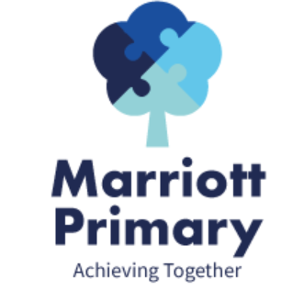
Year 1 Curriculum Newsletter – Spring 2

Maths
In Maths, this term we will be looking at numbers to 50 in more detail. This will include using apparatus to support such as dienes, counters and Numicon. We will then look at addition and subtraction word problems where the children will use what they have learnt in order to read the questions and answer them using key vocabulary.

English
During this term, we will be looking at the books, Lost and Found by Oliver Jeffers and The Snail and the Whale by Julia Donaldson. We will be using the books as a basis for our writing to write diaries, letters, postcards and both character and setting descriptions. In year 1, we would expect children to write simple sentences and begin to use adjectives (describing words) and conjunctions (and, so and because) to join their ideas together.
Children will continue to use their phonics to segment words before spelling them and will be practising sight words or high frequency words that they should be able to spell by the end of the year.

Science
In Science, we will be studying Everyday Materials. By the end of the unit, children should be able to distinguish between an object and the material from which it is made, identify and name a variety of everyday materials, including wood, plastic, glass, metal and describe the simple physical properties of a variety of everyday materials. They will also be able to compare and group together a variety of everyday materials on the basis of their simple physical properties. This will also link with our maths learning in shapes and patterns.
Art / DT  Children will be exploring different types of printing using fruit, sponge, roller prints and developing different patterns. | History  We will be looking at how schools have changed in history and how that is different to how schools are now.
PE  Children will be developing their Kimbles skills and participating in a range of challenge activities mastering their basic movements. | PHSE  We will be looking at healthy and safer lifestyles and how to stay safe.
RE  This terms topic is ‘Who is a Sikh and what do they believe?’ | Music  Children will be learning about Timbre and Rhythmic patterns.

Important Information
- PE is on Monday and Wednesday. Your child may come to school in their PE kit.
- It is important your child reads 3 times a week and sign their log.
- Please complete the homework each week and upload a picture to dojo.

