[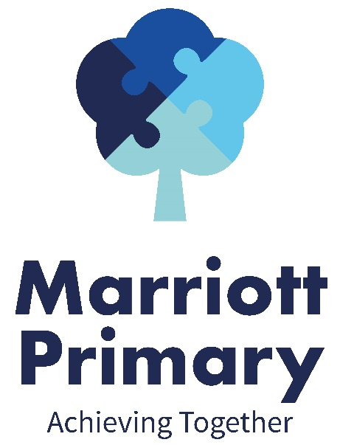](http://www.marriott.leicester.sch.uk/index.asp)

**Science**:

Our science topic this term is “Light”. We will be discover the names of some different light sources, learn about reflection, think about the dangers of sunlight and start to understand shadows and how they work.

**Maths**:

In maths we will be working on the following units: money, statistics, length and perimeter and fractions.

In money we will be learning to calculate in pounds and pence and applying our skills into practical, every day settings. You will need to know that £1 = 100p!

In statistics, we will be using, making and interpreting bar charts, tally charts, pictograms and tables.

Length and perimeter will give us a chance to work with mm, cm and m to measure shapes. We will add these and convert between them too. You will need to know the following:

1m = 100cm 1cm = 10mm

We have looked a little at fractions this term in fluent in five. We will be recapping from last year looking at halves, quarters and thirds and finding answers to questions such as ½ of 200, ¾ of 36 and 3/10 of 40.

**English**:

In English we will be hoping to look at ‘The Firework Makers Daughter’ by Philip Pullman. You may have seen some of his work on TV recently.

Our writing this term will be focusing on story-telling and newspapers. We will be creating a story opener to create suspense on the theme of your garden at night. We will also be writing newspaper reports about the invention of the lightbulb!

The key skills we will focus on are:

1. Writing expanded noun phrases with adventurous vocabulary e.g. the **stern** officer
2. Using adverbs of manner to explain how things are done e.g. the stern officer spoke **loudly**
3. Using prepositional phrases to say where or when it happened e.g. the stern officer spoke loudly **in the training ground**.

Y3 Curriculum Newsletter

Spring 2 – 2020/21

**Other information:**

Children should read to an adult at least three times every week. This should then be recorded in the reading record. Children who have read three times during a week will then receive a token and a raffle ticket. The tokens go towards helping the class to try and win a film afternoon and the raffle tickets are chances to win a prize. Reading books need to be handed in on a Friday so that they can be changed and returned to you on Tuesday after a quarantine period.

Homework is given out on a Friday to be returned the following Thursday. It will always consist of spellings (on which there is a weekly test), maths and reading comprehension. Please do not return the sheets due to current regulations. Evidence of homework can be put on Dojo by taking a photograph of it. If you need any help with the homework please feel free to contact the teacher through Dojo.

PE is on and and children should come to school on these days in their PE kit.

Children are encouraged to bring water bottles to school as research shows that keeping well hydrated leads to better learning outcomes. Please send them each day with a named bottle.

**RE**:

Our topic this term is to continue with “How does a Christian follow Jesus”. We will think about the actions of Christians, why Jesus is seen as inspirational to Christians, values of Christianity, and the different Christian groups.

**Computing**:

Our computing links to our maths; our unit is called, “Is there a way to show data clearly”. For this we will be using 2question to create and interrogate branching databases.

**PE**:

In PE we will be doing orienteering and gymnastics. In orienteering we will be learning how to use equipment and maps to navigate around, solving puzzles and finding out facts along the way. In gymnastics we will focus on learning some simple movements and putting them together into longer routines. They will focus on body control.

**PSHE**:

Our first PSHE topic will be “Managing Risks”. In this unit we will learn about risky situations we may encounter in our lives including physical, mental and emotional risks, and how to deal with them.

**Geography**:

We will be learning all about the country of Italy. We will be comparing it to where we live and learning about the landmarks, both natural and man-made, and thinking about how it is similar and different to England.

We will also work on our key geographical skills, using atlases, maps and keys and locating the countries and features of Europe.