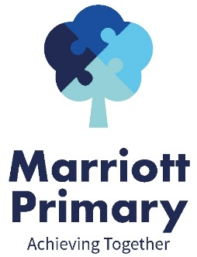
YEAR 6 CURRICULUM NEWSLETTER
SPRING 2
Welcome to the Year 6 newsletter for the second half of the Spring term. This term is set to be very busy as we continue to prepare the children for their transition from primary to secondary school, ensuring they are ready for the requirements of Year 7.
SATs | These will not be taking place in the format that they normally do. Once we know more we will let you know.
ENGLISH | This half term the children will write:  - A persuasive leaflet  - A balanced argument  - An informal postcard  Our class books will be continuing:  - Pandora’s box  - Theseus and the Minotaur  - Who let the Gods out?  In pieces of writing the children will:  - Plan their writing by:  - identifying the audience for and purpose of the writing (knowing who the reader is)  - noting and developing initial ideas, drawing on reading and research where necessary  - in writing narratives, considering how authors have developed characters and settings in what pupils have read, listened to or seen performed  - Draft and write by:  - selecting appropriate grammar and vocabulary  - in narratives, describing settings, characters and atmosphere and integrating dialogue to convey character and advance the action  - using a wide range of devices to build cohesion within and across paragraphs  Cohesion needs to be achieved in a sentence, within a paragraph and across paragraphs for a text to make sense. Cohesion can be achieved by using: adverbials, punctuation, repetition, pronouns, synonyms and a variety of conjunctions.  - using further organisational and presentational devices to structure text and to guide the reader [for example, headings, bullet points, underlining]  - Evaluate and edit by:  - reading their own and other children’s writing and making edits.  - proposing changes to vocabulary, grammar and punctuation to enhance effects and clarify meaning  - ensuring the consistent and correct use of tense throughout a piece of writing  - ensuring correct subject and verb agreement when using singular and plural, distinguishing between the language of speech and writing and choosing the appropriate register  - proof-read for spelling and punctuation errors
MATHS | PERCENTAGES  Pupils will explore how to calculate percentage of numbers and quantities. They will be learning about how to solve for percentage change and use percentage to compare amounts. Pupils will find the percentage of a whole number. This will involve both division and multiplication skills. They will then move on to finding the percentage of a quantity, measured in amounts such as litres and millilitres. Pupils will also be looking at difference and percentage change before finally moving on to using percentage as a way to compare numbers and amounts.  ALGEBRA  Pupils will learn some of the conventions of algebra in the context of patterns and real-life problems. The chapter begins with lessons describing patterns and using a letter to denote a variable. Pupils then move on to write expressions using the four operations and fractions, while continuing to look for patterns and determine rules. Pupils write and evaluate algebraic expressions and use formulae to solve problems in real-life contexts.  CONVERTING UNITS OF MEASURE  Pupils will be reviewing how to calculate metric measures and Convert metric measures. They will also be calculating with metric measures including miles and kilometres.
SCIENCE | EVOLUTION AND INHERITANCE  Children will be taught to:  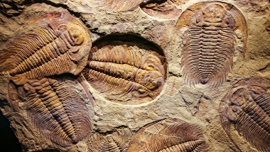  - recognise that living things have changed over time and that fossils provide information about living things that inhabited the Earth millions of years ago  - recognise that living things produce offspring of the same kind, but normally offspring vary and are not identical to their parents  - identify how animals and plants are adapted to suit their environment in different ways and that adaptation may lead to evolution.
HISTORY  This topic will continue. | ANCIENT GREECE - Has Ancient Greece had an influence on modern Britain?  Key facts the children will be taught.  - 800BCE Greek civilisation slowly emerged again.  - The people of Athens created the idea of democracy- only males who were not slaves could vote.  - They created:  The jury system  A number system and the idea of geometry  Sophisticated sculpture and architecture  - There are many famous scientists from Greece and they were famous for their medical knowledge.  - In Britain it was the Bronze Age and the Iron Age.  - They created the Olympic games.  - Women were not allowed to take part at first or be spectators.
GEOGRAPHY | 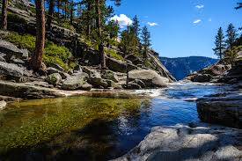  RIVERS  Pupils will be taught to:  - Explain the water cycle and where our water comes from  - Locate the key rivers of the world  - Name the features of a river  - Explain erosion and deposition  - Explain the impact of damming rivers
DT  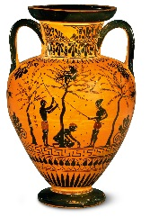  This topic will continue | SCULPTURE – GREEK POTS  In this unit the children will find out what Greek pots were used for and how this altered their design. They will look at ancient Greek artefacts to find out about history and identify what images were used on clay pots and why. They will design their own repeating patterns that could have been used on a Greek pot, create their own Greek pot design – in keeping with the time period – and finally use clay to produce their own pot.  We are aiming to actually create our Greek pots as the children will not have done this yet.
ART | Card making for Easter and Mother’s day
SPELLING | Children will be taught the spelling patterns:  - Words with a long /e/ sound spelt ‘ie’ or ‘ei’ after c (and exceptions)  - Words with the long /e/ sound spelt ‘ie’ or ‘ei’ after c (and exceptions)  - Word families based on common words, showing how words are related in form and meaning  - Words with endings which sound like /shuhl/ after a vowel letter  - Words with a ‘soft c’ spelt /ce/
PE | TEAM BUILDING  In this unit the children will use simple maps to orientate and take part in problem solving and team challenges giving their ideas and opinions. They will listen and give constructive feedback to other children’s ideas as well as compare their performances with previous ones and demonstrate improvement to achieve their personal best, through Teacher feedback and support and through peer assessment and discussion.
PSHE | DIVERSITY AND COMMUNITIES  Pupils will:  - be able to recognise aspects of their identity and understand how other people can influence their perception of themselves.  - be able to describe the ethnic make up of their community and different groups that live in Britain.  - recognise the negative effects of stereotyping and prejudice.  - know about how they and others, including volunteers, contribute to the community.  - understand about the role of the media and its possible influences.  - understand some ways of caring for the environment and the contribution they can make.
ICT | TEXT ADVENTURES  The children will learn to understand the term ‘text adventure’ and use different programs to effectively plan and create their text adventure. They will learn to debug their work accurately and effectively and se others’ work to adapt their own. They will use ‘functions’ command as well as ‘if/else’ statements and ‘repeat’ statements.
OTHER INFORMATION | Children should read to an adult at least three times every week. This should then be recorded in the reading record. Children who have read three times during a week will then receive a token and a raffle ticket. The tokens go towards helping the class to try and win a film afternoon and the raffle tickets are chances to win a prize.  Homework is given out on a Friday to be returned the following Thursday. It will always consist of spellings (on which there is a weekly test), maths and reading comprehension. Please do not return the sheets due to current regulations. Evidence of homework can be put on Dojo by taking a photograph of it. If you need any help with the homework please feel free to contact the teacher through Dojo.  PE is on Monday and Thursday so children should come to school on these days in their PE kit.  Children are encouraged to bring water bottles to school as research shows that keeping well hydrated leads to better learning outcomes. Please send them each day with a named bottle.

