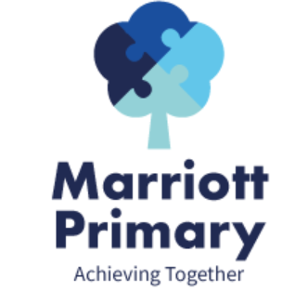
Year 1 Curriculum Newsletter – Summer 1
Maths
In Maths, this term we will be looking at Measuring, focusing on weight and volume. Children will carry out simple investigations using different measuring apparatus such as beakers, scales and also non-standard units to measure. They will then move on to Multiplication and division more detail. We will focus counting in 2’s, 5’s and 10’s, making equal groups and sharing objects. They will also be making doubles and learning to add equal groups. This will include using apparatus to support representing and exploring such as cubes, counters and the use of arrays. We will then move on to Fractions where children will learn all about half, quarter and whole. They will explore by finding and making these fractions using different shapes, objects and quantities.

English
During this term, we will be looking at the books, Where the Wild Thing Are by Maurice Sendak and Princess Smartypants by Babette Cole. We will be using the books as a basis for our writing to write, letters, postcards and both character and setting descriptions. In year 1, we would expect children to write simple sentences and begin to use adjectives (describing words) and conjunctions (and, so and because) to join their ideas together.
Children will continue to use their phonics to segment words before spelling them and will be practising sight words or high frequency words that they should be able to spell by the end of the year.

Science
In Science, we will be studying Everyday Materials including wood, plastic, metal, water and rock. By the end of the unit, children should be able to identify and name everyday materials and will have the opportunity to explore the properties of these materials. They will also carry out simple investigations to help them decide which materials are best for different objects. By the end of the unit, children should be able to sort objects by their properties and make a prediction.
Art / DT  Children will be focusing on their sketching skills and linking to our Kings and Queens topic we will be making crowns. | History  This half term our theme is Kings and Queens and our themes topic is ‘Which queen had the most influence Queen Victoria or Elizabeth I?’
PE  Children will be developing their Kimbles skills and participating in a range of challenge activities mastering their basic movements. | PHSE  We will be looking at Rights, Rules and Responsibilities both in school and outside of school.
RE  This terms topic is ‘What can stories teach us?’ | Music  Children will be learning about Classical music, Dynamics and Tempo
Computing
This terms topic is Programming. We will be using Bee-Bots to develop children’s programming skills.

Important Information
- PE is on Wednesday and Thursday. Your child may come to school in their PE kit.
- It is important your child reads 3 times a week and sign their log.
- Please complete the homework each week and upload a picture to dojo.

