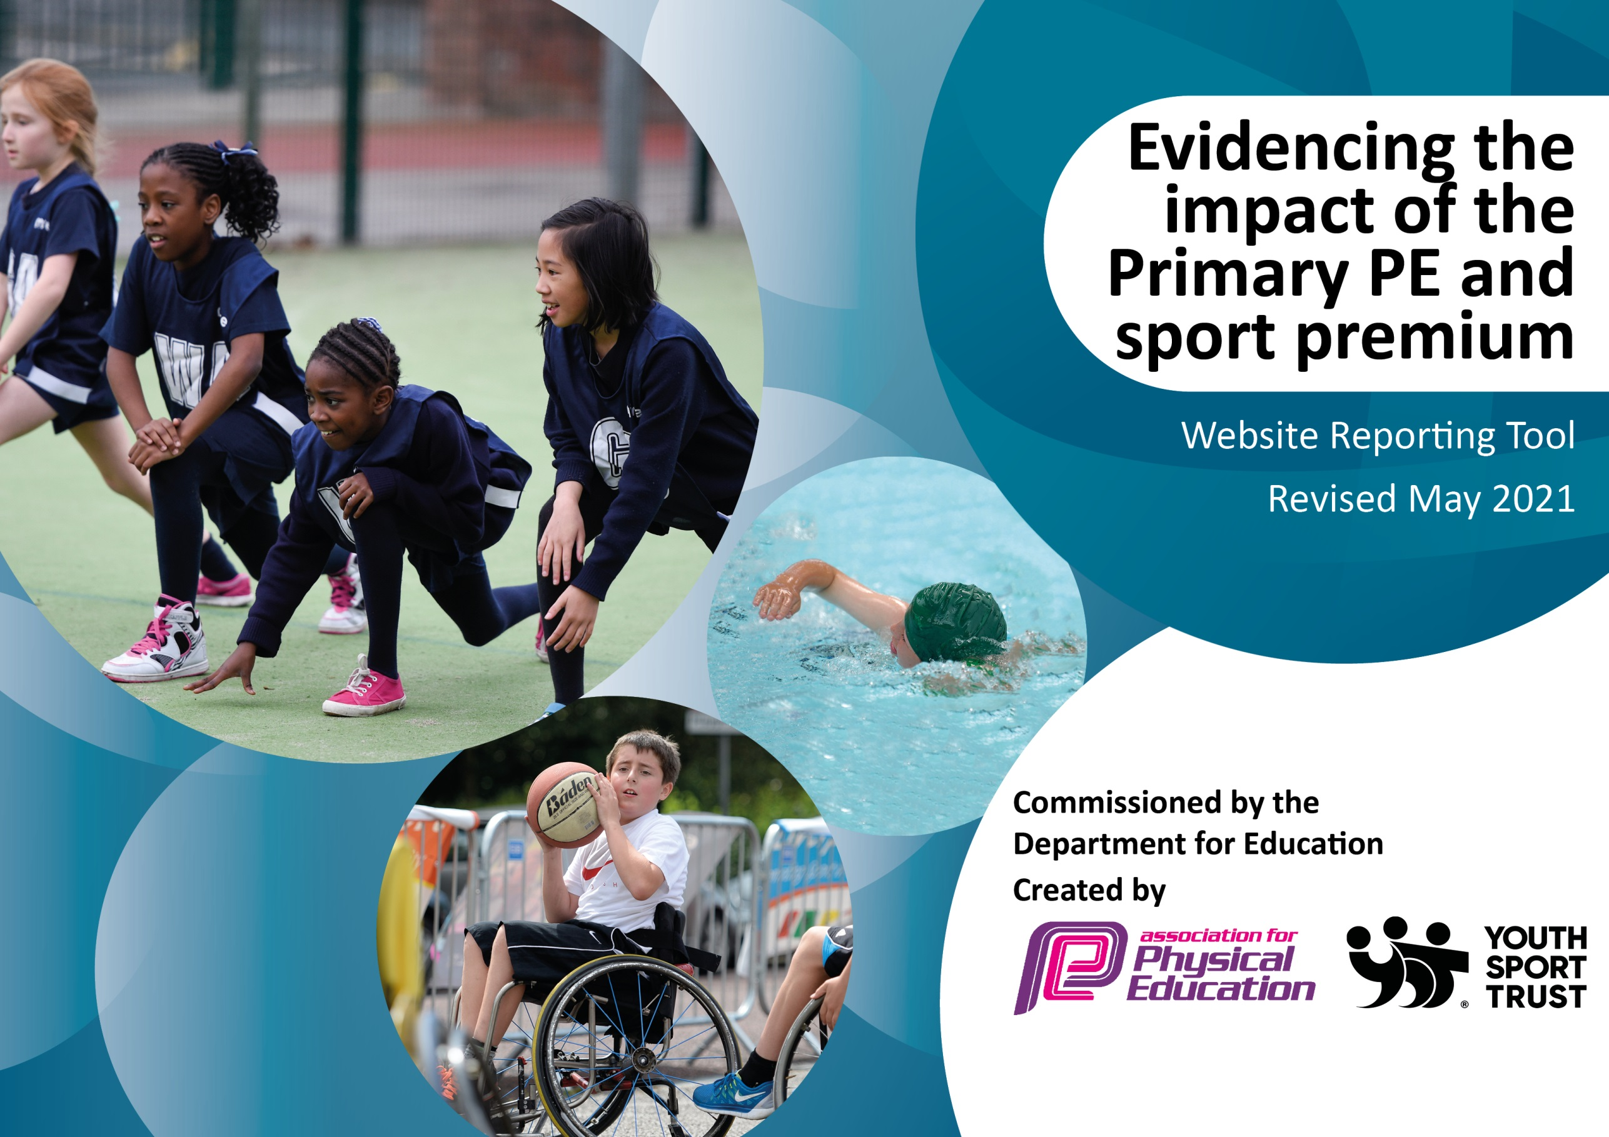

It is important that your grant is used effectively and based on school need. The Education Inspection Framework (Ofsted 2019 p64) makes clear there will be a focus on ‘whether leaders and those responsible for governors all understand their respective roles and perform these in a way that enhances the effectiveness of the school’.

Under the Quality of Education criteria (p41) inspectors consider the extent to which schools can articulate their curriculum (INTENT), construct their curriculum (IMPLEMENTATION) and demonstrate the outcomes which result (IMPACT).

To assist schools with common transferable language this template has been developed to utilise the same three headings which should make your plans easily transferable between working documents.

Schools must use the funding to make additional and sustainable improvements to the quality of Physical Education, School Sport and Physical Activity (PESSPA) they offer. This means that you should use the Primary PE and sport premium to:

- Develop or add to the PESSPA activities that your school already offer
- Build capacity and capability within the school to ensure that improvements made now will benefit pupils joining the school in future years
- The Primary PE and sport premium should not be used to fund capital spend projects; the school’s budget should fund these.
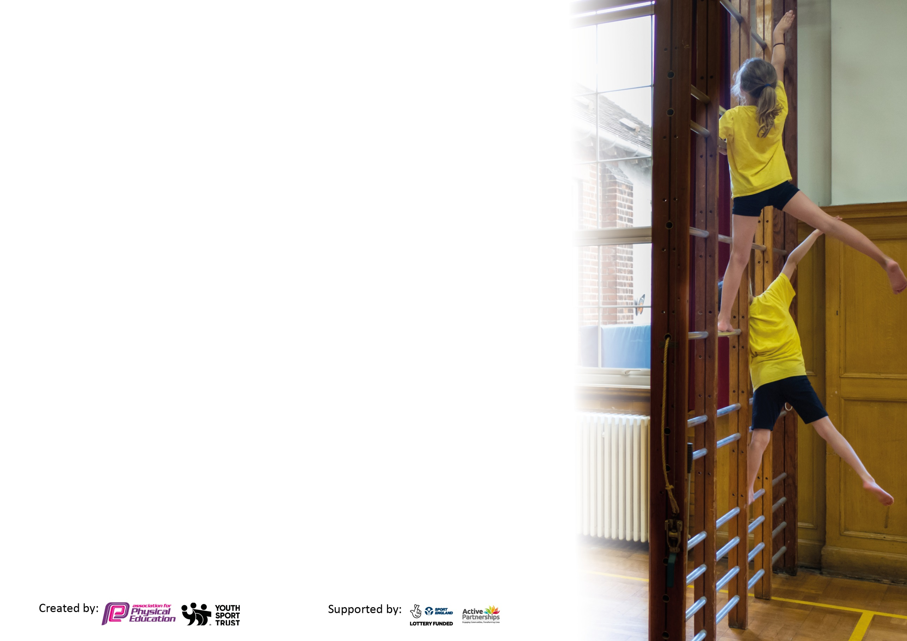
Please visit gov.uk for the revised DfE guidance including the 5 key indicators across which schools should demonstrate an improvement. This document will help you to review your provision and to report your spend. DfE encourages schools to use this template as an effective way of meeting the reporting requirements of the Primary PE and sport premium.

We recommend you start by reflecting on the impact of current provision and reviewing the previous spend.

Schools are required to publish details of how they spend this funding, including any under-spend from 2019/2020, as well as on the impact it has on pupils’ PE and sport participation and attainment by the end of the summer term or by 31st July 2021 at the latest.

We recommend regularly updating the table and publishing it on your website throughout the year. This evidences your ongoing self-evaluation of how you are using the funding to secure maximum, sustainable impact. Final copy must be posted on your website by the end of the academic year and no later than the 31st July 2021. To see an example of how to complete the table please click HERE.

Please note: Although there has been considerable disruption in 2020 it is important that you publish details on your website of how you spend the funding - this is a legal requirement.
Support for review and reflection - considering the 5 key indicators from DfE, what development needs are a priority for your setting and your pupils now and why? Use the space below to reflect on previous spend and key achievements and areas for development.

N.B. In this section you should refer to any adjustments you might have made due to Covid-19 and how these will influence further improvement.
Key achievements to date until July 2021: | Areas for further improvement and baseline evidence of need:
- Maintain Sportsmark Platinum  - Participated in all virtual competitions.  - Keepie Up Football Challenge – Spirit of the Games Winners, Y3/4 Girls were 3rd, Y3/4 Boys were 3rd, Y5/6 Girls were 4th and Y5/5 Boys were 6th.  - 5K Challenge – Y4 were 9th.  - Cricket Challenge – Y6 Group 1 were 3rd and Group 4 were 10th.  - Football Accuracy Challenge – Y3/4 Girls were 3rd, y3/4 Boys were 5th and Y5/6 Girls were 8th.  - Football Speed Challenge – Y3/4 Girls were 7th.  - Produced the videos for the SSPAN Sportshall Athletics promotion.  - Sportshall Athletics  Y3 1st in the West, 3rd in the City  Y4 1st in the West, 3RD in the City  Y5 2nd in the West, 3rd in the City  Y6 8th in the West, 3rd in the City  Y3/4 representing West Leicester at the Level 3 County Finals  Nationally Y3/4 were 39 out of 566 teams and Y5/6 were 121 out of 881 teams.  - Inclusive Sportshall Athletics  1st in the West  2nd in the County  Chelsea won Individual Gold  - Filbert Fox Challenge – Y3/4 Boys were 8th, Y5/6 Girls were 2nd and Y5/6 Boys were 4th.  - Marriott Dance Competition – 2 Duo’s were equal first.  - SSPAN Dance Competition – Group were 3rd, Duo 1 were 8th and Duo 2 were 9th.  - Blake won a Premier League Primary Stars Poetry Competition.  - Move It March Challenge – 1st. Y2-Y6 logged 608169 Active minutes.  Keanna Y3 Winner, Zion Y3 Winner, Chantelle and Kayla-Marie Y4 winners.  - Skipping Competition – Emily F was 3rd.  - Basketball Competition – Aryan was 3rd for Y5 Boys. | - Introduce Yoga into the school to help to improve Health and Well Being.  - Further develop Leadership skills within the curriculum.  - Introduce an Inclusive Sport Week.

Did you carry forward an underspend from 2019-20 academic year into the current academic year? NO * Delete as applicable
Total amount carried forward from 2019/2020 £0
+ Total amount for this academic year 2020/2021 £19,520 + an extra £1,000 from school towards equipment.
= Total to be spent by 31st July 2021 £19,520

Meeting national curriculum requirements for swimming and water safety.  N.B Complete this section to your best ability. For example you might have practised safe self-rescue techniques on dry land which you can transfer to the pool when school swimming restarts.  Due to exceptional circumstances priority should be given to ensuring that pupils can perform safe self rescue even  if they do not fully meet the first two requirements of the NC programme of study. | Self Rescue taught to all students as part of their swimming lessons in Y3.  Discussed in the classroom in Y6.
What percentage of your current Year 6 cohort swim competently, confidently and proficiently over a distance of at least 25 metres?  N.B. Even though your pupils may swim in another year please report on their attainment on leaving primary school at the end of the summer term 2021.  Please see note above. | 27%
What percentage of your current Year 6 cohort use a range of strokes effectively [for example, front crawl, backstroke and breaststroke]?  Please see note above. | 27%
What percentage of your current Year 6 cohort perform safe self-rescue in different water-based situations? | 100%
Schools can choose to use the Primary PE and sport premium to provide additional provision for swimming but this must be for activity over and above the national curriculum requirements. Have you used it in this way? | Not this year as there has been no school swimming.

Action Plan and Budget Tracking
Capture your intended annual spend against the 5 key indicators. Clarify the success criteria and evidence of impact that you intend to measure to evaluate for pupils today and for the future.

Academic Year: 2020/21 | Total fund allocated: £19,520 | Date Updated: 8th June 2021
Key indicator 1: The engagement of all pupils in regular physical activity – Chief Medical Officers guidelines recommend that primary school pupils undertake at least 30 minutes of physical activity a day in school |  |  |  | Percentage of total allocation:
 |  |  |  | £326.23
Intent | Implementation |  | Impact
Your school focus should be clear what you want the pupils to know and be able to do and about  what they need to learn and to  consolidate through practice: | Make sure your actions to achieve are linked to your intentions: | Funding allocated: | Evidence of impact: what do pupils now know and what can they now do? What has changed?: | Sustainability and suggested next steps:
KS2 - Daily Mile – to improve the Health of students by increasing their activity by an extra 15 minutes.  KS1 – Kimbles/Activate – students to complete a Kimbles /Activate session each day.  Bikeability training for Year 6  Walk to school  Bike or scoot to school  Active lunchtimes for students.  Inter Class and Level 1 Competitions  Supermovers/Go Noodle  PE Dojo  Children and young people should aim  to minimise the amount of time spent  being sedentary, and when physically  possible should break up long periods  of not moving with at least light  physical act Children and young people should aim  to minimise the amount of time spent  being sedentary, and when physically  possible should break up long periods  of not moving with at least light | Have different routes for the students to complete. Competition between the classes. Try it skipping, dribbling etc.  Teachers select different routines for the students to perform.  Encourage students to bike to and from school.  Staff to record those students who are walking to school, so that they can achieve their badges.  A range of activities for students to be involved in at lunchtime. Some competitions also taking place to encourage students.  Skipping every Tuesday lunchtime.  Training for lunchtime supervisors.  Competitions between the classes to increase participation and raise activity levels. Run competitions at the end of a unit of work.  Staff to choose areas which they want to work on with their class to get them active in the classroom e.g. 8 X Tables with Filbert Fox  During lockdown daily challenges were put on the PE Dojo page for students to try.  . | Skipping Coach  £160  Equipment for lunchtime  £166.23  Staff Training  Use PE Equipment  Time | All pupils involved in an additional 15 minutes of exercise a day.  All pupils involved in an additional 15 minutes of exercise a day.  An increase in students bringing their bike to and from school.  Students receiving their badges when they achieve targets. Improved health, social and environmental benefits.  Students involved in different activities at lunchtime e.g. Table Tennis, Skipping, Cricket, Netball, Basketball etc.  Students involved in representing their class and participating in Level 1 Competitions, they gain confidence, discipline and self-belief.  Students are active during lessons and use the routines to help learn different areas of the curriculum. They know that you don’t always have to sit in the classroom to learn other topics.  Students participating in different activities and posting videos and scores. Students learning new skills with some of the challenges.  WIDER IMPACT  Students are more active in PE lessons.  Improved standards in PE.  Attitudes to learning are improved.  SAT results improved.  Hit the target set by the Chief Medical Officer of being active for at least 30 minutes each day in school, but 60 minutes each day.  Students are less sedentary throughout the day.  Develops movement skills.  Improves muscular fitness and bone strength.  Improved mental wellbeing. | The Daily Mile embedded in the school day.  Kimbles/Activate embedded in the school day.  Encourage students in Y6 to be using their bikes to travel to and from school.  Students receiving their badges when they achieve targets  New bike/scooter sheds available for students to use  Continue to organise activities for students at lunchtime so they can remain active.  Continue to organise Level 1 competitions throughout the year for student’s to be involved in.  Staff to use the resource to support different areas of the curriculum, not the same routine all of the time.  Using PE Dojo to post the virtual competitions for students to participate in.
Key indicator 2: The profile of PESSPA being raised across the school as a tool for whole school improvement |  |  |  | Percentage of total allocation:
 |  |  |  | £0
Intent | Implementation |  | Impact
Your school focus should be clear what you want the pupils to know and be able to do and about  what they need to learn and to  consolidate through practice: | Make sure your actions to achieve are linked to your intentions: | Funding allocated: | Evidence of impact: what do pupils now know and what can they now do? What has changed?: | Sustainability and suggested next steps:
Celebration Assembly to ensure the whole school is aware of the importance of PE and School Sport and to encourage and inspire students to be involved.  Noticeboards celebrating the success of our students and raising the profile of Physical Education and School Sport.  Trophy Cabinet  Social Media – Marriott Twitter  PE Dojo page  National School Sport Week | Achievement celebrated in Assembly, achievements, results, certificates etc. presented.  Keep all of the displays up to date with the relevant information, competitions, trips, successes and progress. Different noticeboards for Physical Education, Physical Activity, and School Sport.  Trophy Cabinet bought previously and all awards and trophies are on display.  Update Social Media when at events and with the work going on in school so parents are informed of what we are doing.  Update PE Dojo page with upcoming events and competitions. Celebrating successes.  Post videos and photos of student’s work.  Celebrate National School Sport Week by teaching different subjects in a practical way. Try different sports during this week. | SSPAN membership and entry to Leagues.(cost in Section 5)  Printing posters for display (costs met by school). | Pupils enjoy being involved in the Assembly and having their successes celebrated. Achievements can be shared with their parents.  Noticeboards in the PE Corridor celebrate Physical Education, Physical Activity & School Sport.  This encourages students to get involved and enjoy representing their school.  Trophy Cabinet displays the achievements of our students.  Allow us to share our activities and achievements with the wider community – parents, teachers, governors and other school etc.  Students and parents know what events and competitions are coming up. Students and parents can look at the work they are producing in lessons, competitions and events. Students/parents sometimes send messages and photos/videos about what has been posted.  WIDER IMPACT  Pupils are proud to be involved in assemblies and have their achievements displayed on the noticeboards, school website and school twitter etc.  Increased self-esteem /confidence has an impact on learning across the curriculum and when we attend events.  Parents and students know what we are involved in and can celebrate the successes. | SLT see the benefits of the raised profile and continue their commitment to fund Primary PE and School Sport.  Continue to celebrate the amazing work that we are doing at Marriott. Compete/participate in a variety of events for students to be involved in.  Will need a bigger Trophy Cabinet in the future as it is very full.  Keep making posts on Social Media to celebrate the achievements of Physical Education, Physical Activity and School Sport at Marriott.  Continue to regularly make posts about everything PE so parents and students are informed.

Key indicator 3: Increased confidence, knowledge and skills of all staff in teaching PE and sport |  |  |  | Percentage of total allocation:
 |  |  |  | £10,511
Intent | Implementation |  | Impact
Your school focus should be clear | Make sure your actions to | Funding | Evidence of impact: what do | Sustainability and suggested
what you want the pupils to know | achieve are linked to your | allocated: | pupils now know and what | next steps:
and be able to do and about | intentions: |  | can they now do? What has
what they need to learn and to |  |  | changed?:
consolidate through practice:
School employs a specialist PE Teacher one day a week to work with the PE Co-coordinator and all of the staff in rotation throughout the year.  CPD provided for staff throughout the year by the PE Specialist or with Future Active or other outside agencies.  Resources available for staff to access | Use Staff questionnaire to identify areas of training required.  PE Teacher and class teachers to identify what activities will develop their knowledge.  Organise training sessions for staff in a variety of activities e.g.  LTA Teacher Training Course  SSPAN Conference Online  Place2be’s Mental Health Champions  AfPE Webinar - Physical Education and the Education Inspection Framework  AfPE Webinar – Awesome Curriculum Design in 5 ways  YST Webinar – Reviewing your PE Curriculum: Ofsted PE Deep Dive  YST Webinar – Primary PE Curriculum Design and Delivery  Safe Practice in PE Book available for staff.  YST Membership  IMOVES Dance Health & Well Being Package  Swim Charter  Kimbles Online Platform | £10,411  CPD  Free  Free  Free  Free  Free  Free  Free  £100 | Improved knowledge for Teachers and Teaching Assistants, so they are more confident when teaching PE.  Increased confidence for running activities at lunchtimes and after school.  Subject Leader more confident when undertaking lesson observation, able to provide feedback and lead discussions.  PE Teacher confident to lead or organise the relevant training for staff.  Teachers more confident when teaching PE because of improved subject knowledge.  Staff use their knowledge to run extracurricular activities, assist on Sports Trips and run activities at lunchtime.  Resources available for staff to access.  WIDER IMPACT  Skills, knowledge and understanding of pupils are increased significantly.  Pupils enjoy Physical Education, Physical Activity and School Sport, they are keen to participate, demonstrate and show a desire to learn and improve. Staff have the knowledge, skills and confidence to inspire children when participating. | All staff will feel supported to be confident when delivering PE and Sport both within the Curriculum and School Sport.  Staff continue to be offered CPD to develop their knowledge in different activities.  Staff to identify if they require cover to attend courses.  Purchase and make resources for staff to access to develop their knowledge.
Key indicator 4: Broader experience of a range of sports and activities offered to all pupils |  |  |  | Percentage of total allocation:
 |  |  |  | £4,083.53
Intent | Implementation |  | Impact
Your school focus should be clear | Make sure your actions to | Funding | Evidence of impact: what do | Sustainability and suggested
what you want the pupils to know | achieve are linked to your | allocated: | pupils now know and what | next steps:
and be able to do and about | intentions: |  | can they now do? What has
what they need to learn and to |  |  | changed?:
consolidate through practice:
Additional achievements:  Continue to offer a wide range of activities both within and outside the curriculum in order to get more pupils involved in Physical Education, Physical Activity and School Sport  A PE Curriculum, which is varied and progressive that offers a variety of sports/activities to pupils.  Focus on students who are sometimes reluctant to be involved in PE and School Sport.  Y6 Girls PE Group – building confidence.  Physical Education equipment purchased so students can access the curriculum and extracurricular activities.  Sports kit required for representing the school at Competitions, Festivals or Events. | Arrange for external coaches to work with staff in lessons, clubs or Health Week.  Leicestershire Cricket  Kimbles Health Week  Skipping Health Week  SPARX – Internally  Leicester Tigers  Leicester City  Balanceability - SSPAN  Students are taught a curriculum which includes games, athletics, swimming, outdoor activities, dance and gymnastics.  Buy Yoga mats to encourage students to develop their physical and emotional wellbeing.  Work with a group of girls from Y6, using different activities to the curriculum to develop their confidence, communication skills and leadership skills.  PE Equipment purchased.  Sport Team Kit purchased | £240  £440  £523.95  £2879.58 | A variety of extra-curricular clubs offered throughout the year, which are run by Teachers and Teaching Assistants, staff are confident running these clubs.  Students have the opportunity to be involved in a variety of different sports and activities which develops their skills and knowledge.  Students develop confidence to be more involved in Physical Education lessons and represent the school at Sport Competitions.  New activity to be introduced to develop the wellbeing of the students.  The girls are confident to talk and take a lead in activities. They are fully involved in their PE lessons.  Students have the equipment needed to participate in Physical Education, Physical Activity and School Sport.  Students proud to represent the school in their Marriott kit when they attend Competitions, Festivals and Events.  WIDER IMPACT  Improved behaviour in school.  Students actively involved in Physical Education lessons.  Students want to be involved in Physical Education, Physical Activity and School Sport.  Reluctant students engaged in Physical Education, Physical Activity and School Sport. | Staff work together and share good practice, which develops confidence and staff more willing to support competitions and clubs.  Hope to expand the range of extra-curricular clubs.  Provide opportunities to engage students to develop confidence and a joy for Physical Activity.  Identify students who would benefit from a different approach to Physical Activity or want to be involved in female only Physical Activity or Sport which will develop their confidence.  Introduce yoga as an activity to help students develop strength, body control and emotional wellbeing.  Start an extra-curricular yoga club in the new academic year.  Introduce a similar group next academic year.  Monitor what equipment needs to be replaced and/or purchased.  Purchase equipment that is an investment required for the curriculum.  Purchase PE kit that is required for representing Marriott at Competitions, Festivals and Events.

Key indicator 5: Increased participation in competitive sport |  |  |  | Percentage of total allocation:
 |  |  |  | £4,190
Intent | Implementation |  | Impact
Your school focus should be clear | Make sure your actions to | Funding | Evidence of impact: what do | Sustainability and suggested
what you want the pupils to know | achieve are linked to your | allocated: | pupils now know and what | next steps:
and be able to do and about | intentions: |  | can they now do? What has
what they need to learn and to |  |  | changed?:
consolidate through practice:
Enter a variety of competitions and festivals through Leicester City SSPAN and local Leagues.  Focus on SEND to ensure they are involved in the competitions available to them  Year 6 Park Day  Organise a range of Level 1 Competitions in school | Enter all of the competitions provided though Leicester City SSPAN including all of the SEND competitions.  All competitions were held virtually this year.  Leagues did not run this Academic year due to Covid19.  Have a calendar of events for the Academic Year.  Transport  Pitch Hire  Students compete against each other at the end of a unit of work or against the other class.  SSPAN Membership 2021-2022  Football League 2021-2022 | £1,320  £870  £1550  £450 | We are involved in all of the competitions, we track all of the students who represent the school in these competitions.  We run Level 1 competitions so all student can compete throughout the year.  Participation in competitions.  Level 1 – 100%  Level 2 – Y6 – 100%  Y5 – 100%  Y4 – 100%  Y3 – 100%  As all of the competitions have been virtual, the teachers have run the competitions in school which has meant everyone has been able to participate.  Dance competition in school allowed students to perform in front of an audience and judges.  WIDER IMPACT  Improved standards in competition activities.  Girls engaged in Girl only and mixed competitions.  SEND involved in Disability competitions and other competitions. | More CPD for staff involved in running clubs.  Continue membership of Leicester City SSPAN.  Organise competitions with other schools to provide different opportunities for students.  Calendar Level 1 Competitions in school.

Signed off by
Head Teacher:
Date:
Subject Leader: | Stephanie Magee
Date: | June 2021
Governor:
Date:

